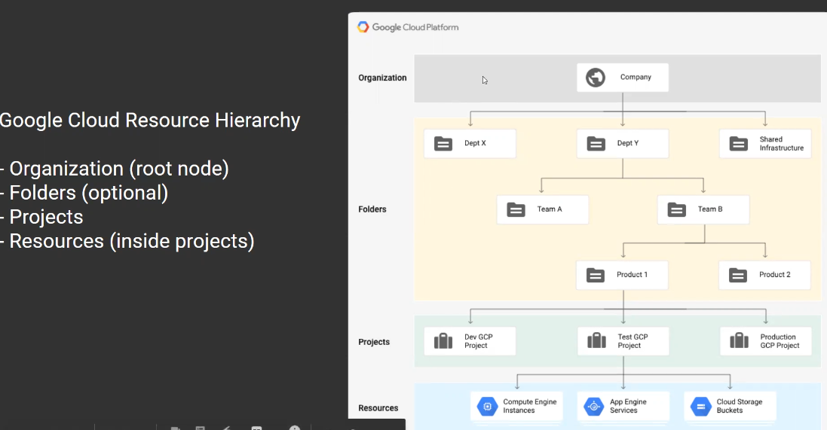

Permissions are inherited to the next level of the resource

3 identifiers to create project

1. Project ID – globally unique – user can create
2. Project Number – google creates
3. Project Name – should be unique in entire gcp

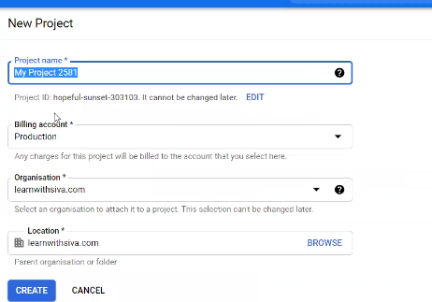

Project name should be available (unique)

Billing account – for cost monitoring need billing account.

1. did you implement sdn (software defined network) in cloud env

2. gcp uses rfc 1918 network protocol to connect to other network within gcp

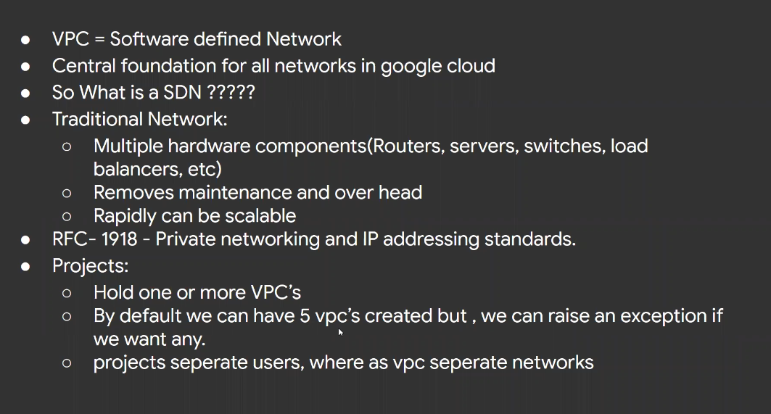

Default vpc – subnets -24, mode is **Auto**

Vpc types

Auto vpc

Custom vpc

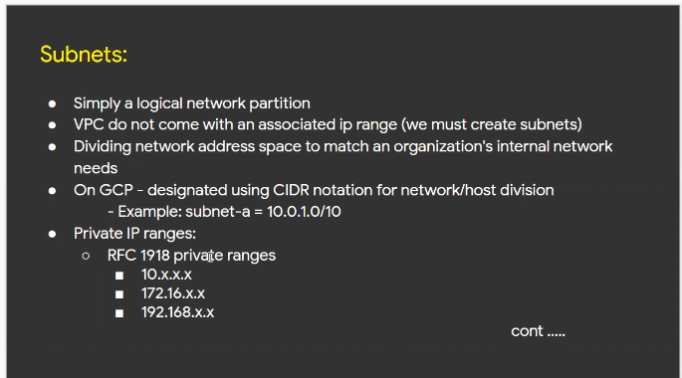

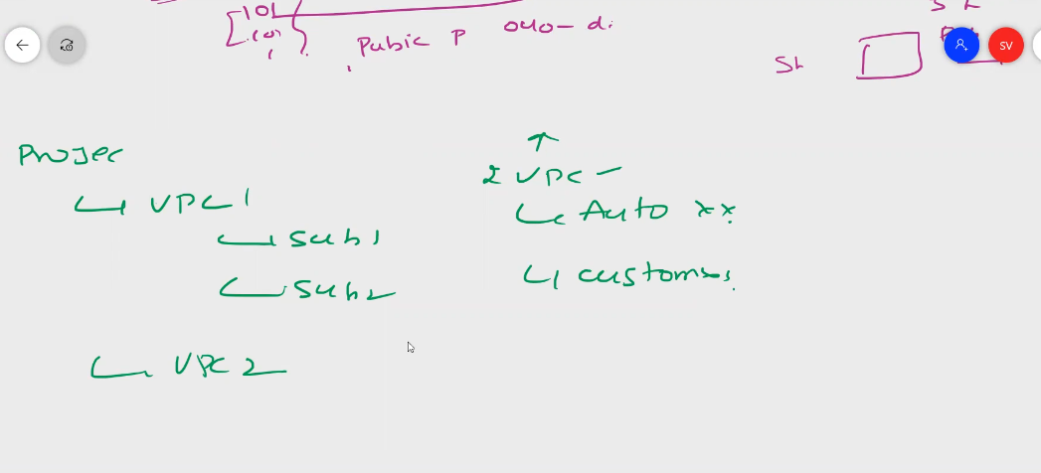

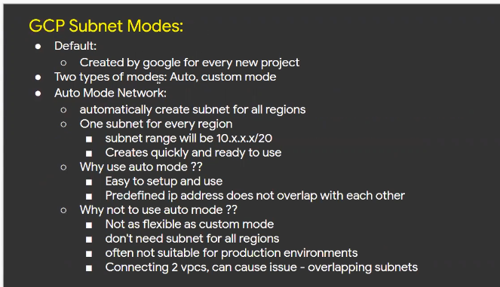

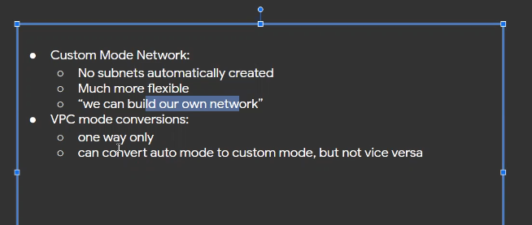

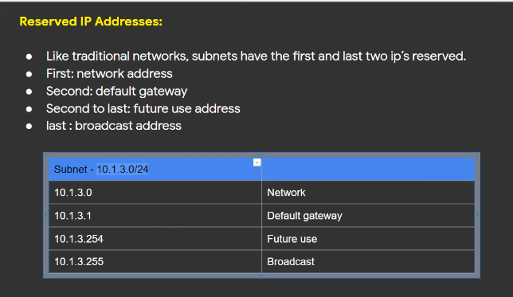

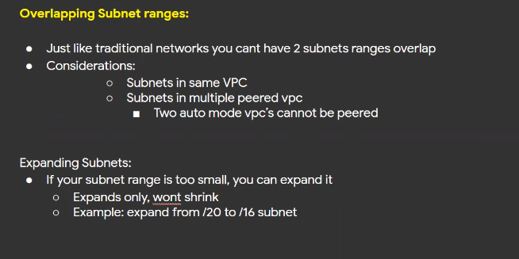

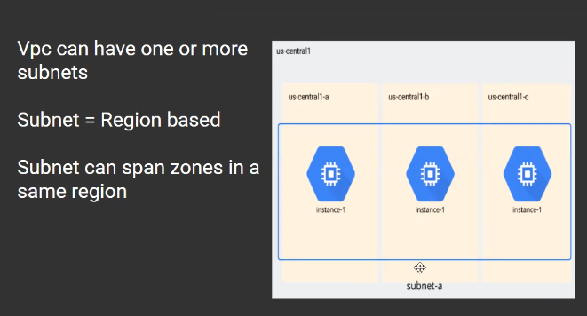

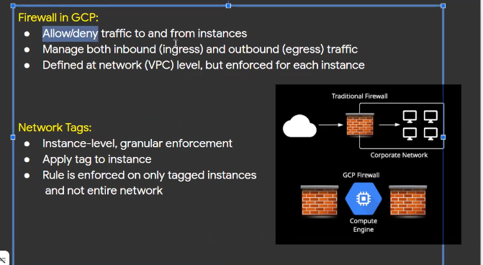

Google vpc is not region wide, it is project based and global. We can create multiple vpcs within project, it works like a network between multiple regions

0Subnets are implemented region level

Network communication happens through private network to multiple regions, which is not happens in aws and azure, these vpcs are region level

**IAM**

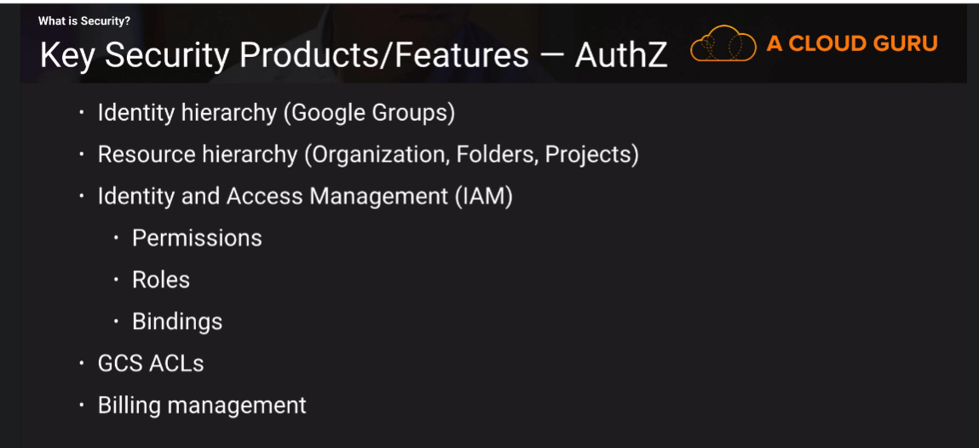

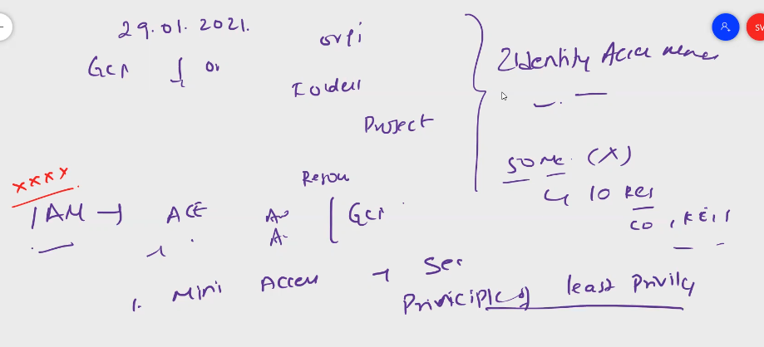

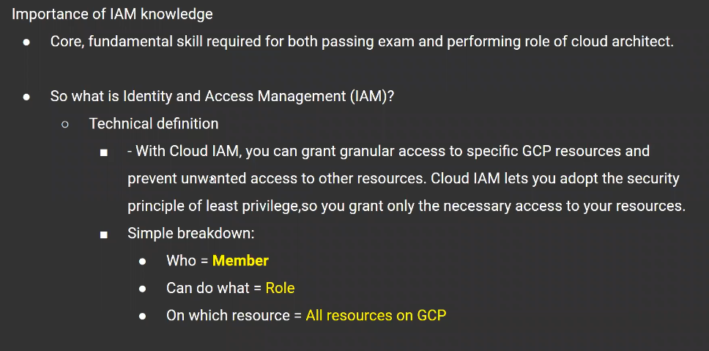

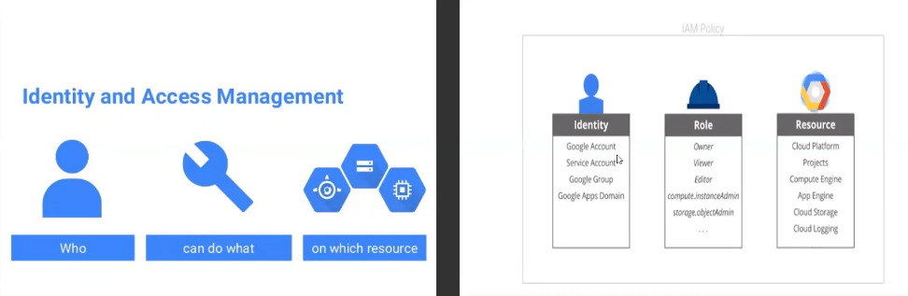

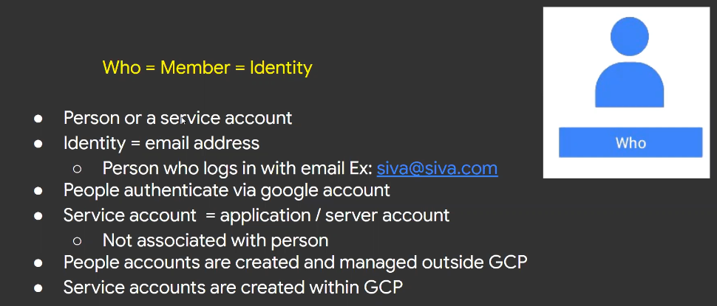

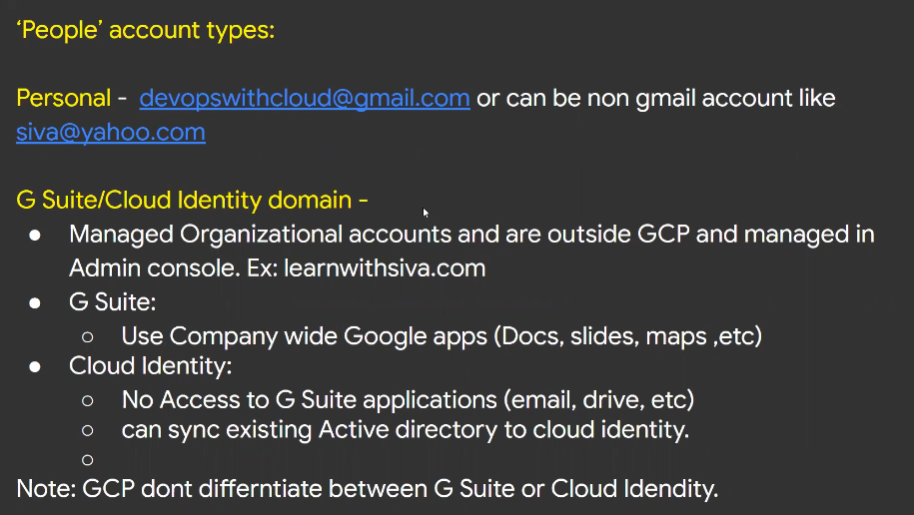

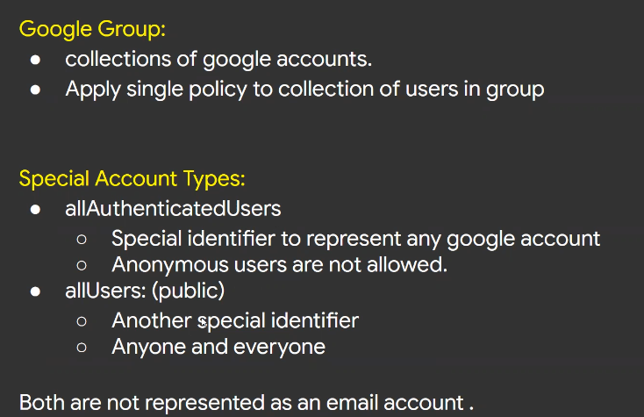

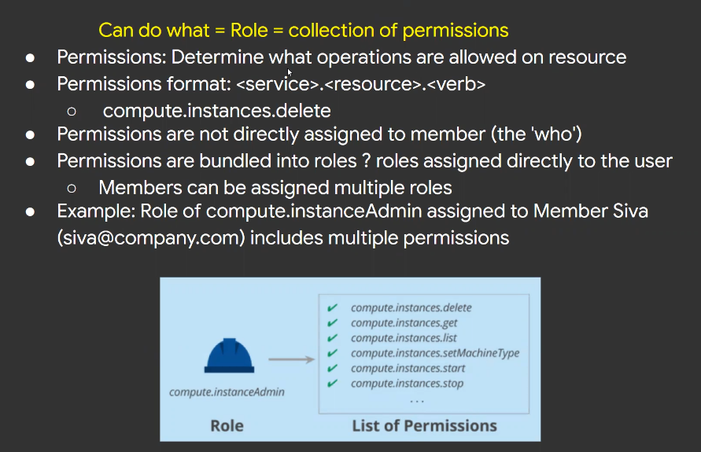

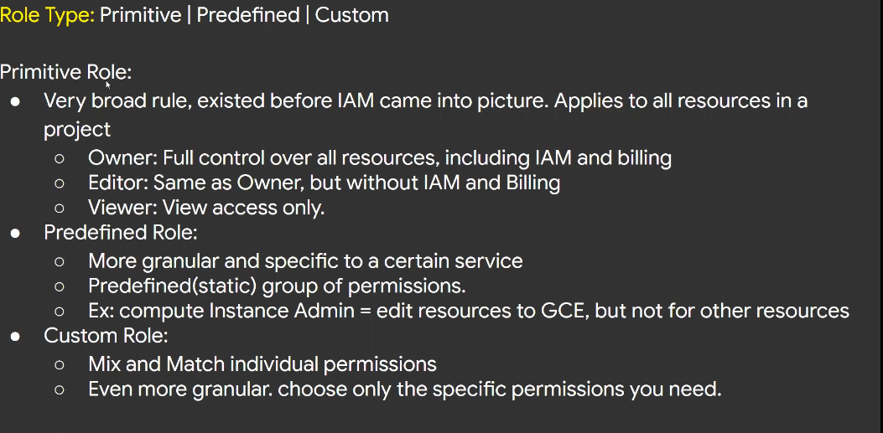

Service accounts are implemented project level not org level

**Roles are two types**

1. Google managed roles
2. Custom roles

Total roles around 724 = permissions 3875

To use cloud resources, we need to enable API of particular resource ex- k8s, cloud run, compute engine etc…

Alpha, beta and general availability – models

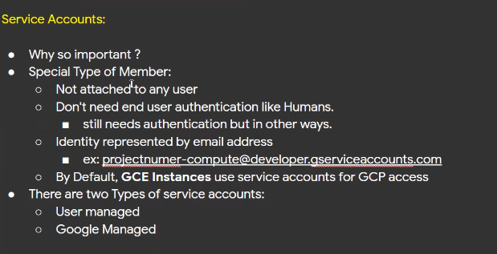

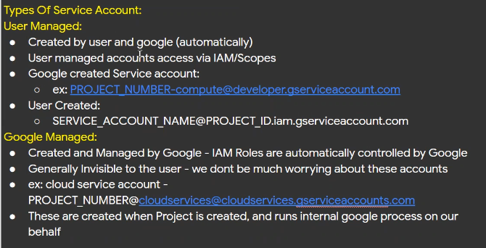

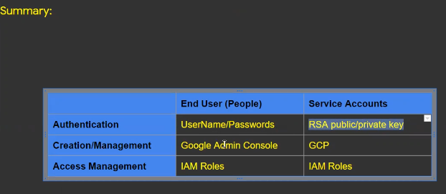

For testing the website or application locally from google cloud can use web preview option

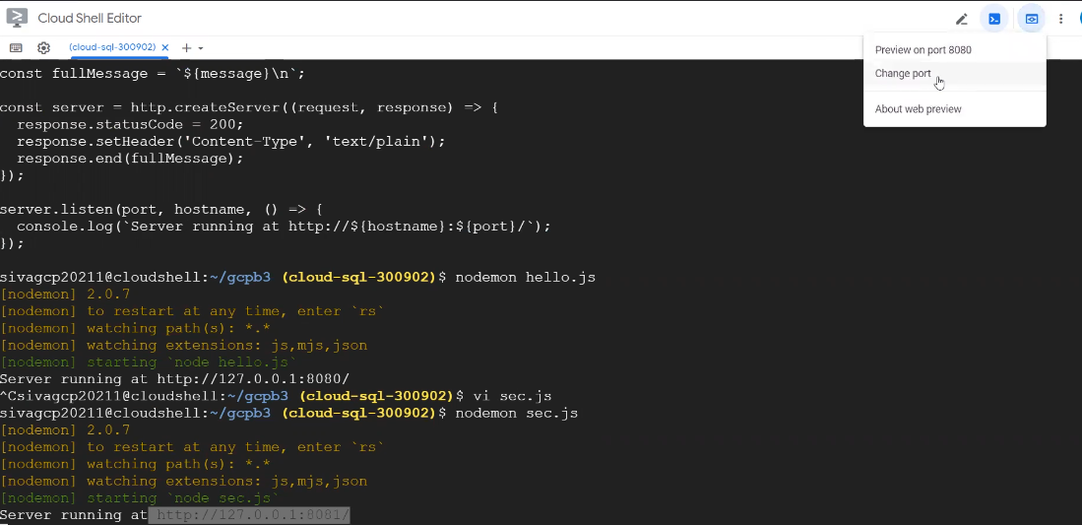

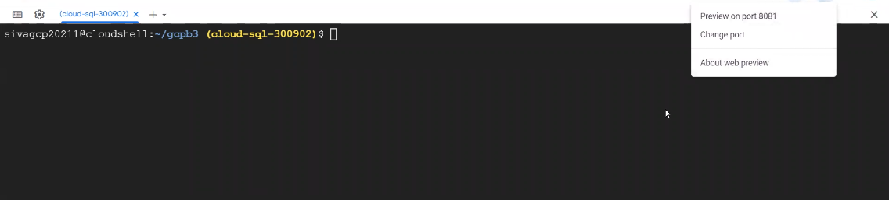

VPC

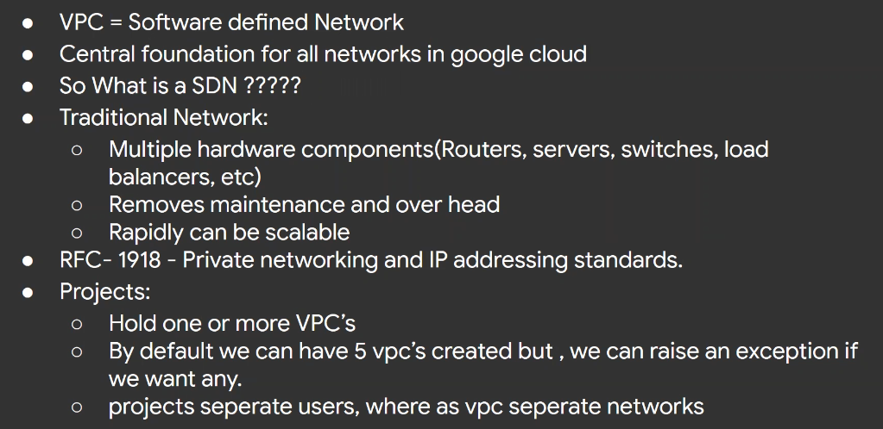

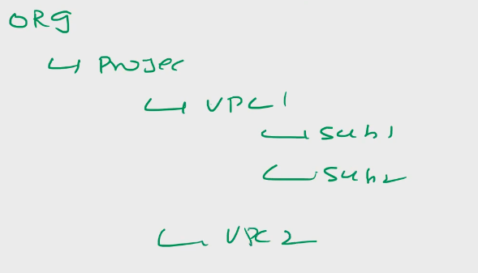

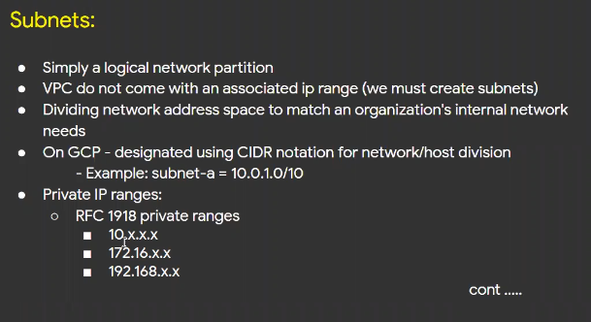

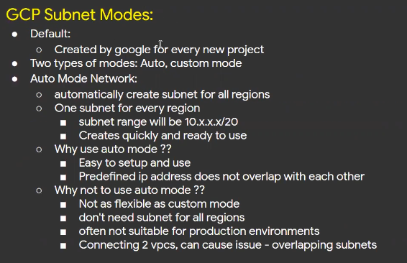

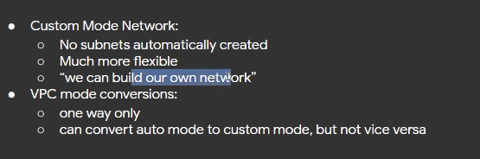

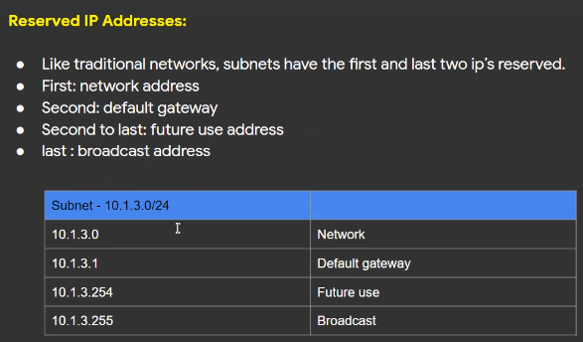

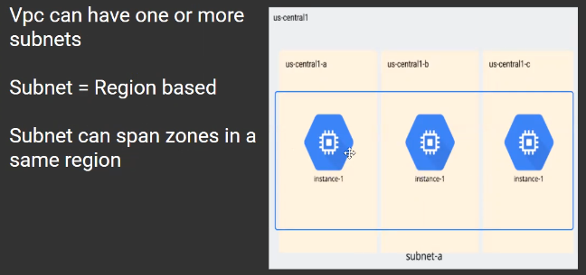

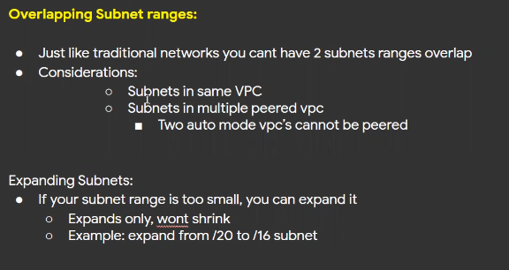

By default vpc creates 24 subnets with default ip address ranges

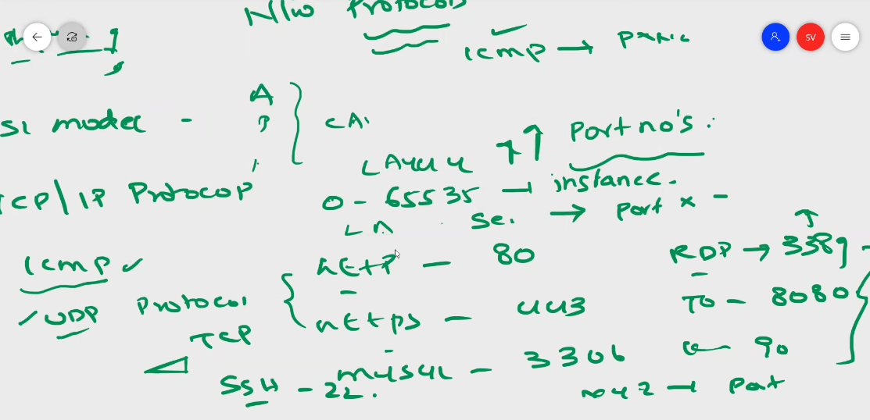

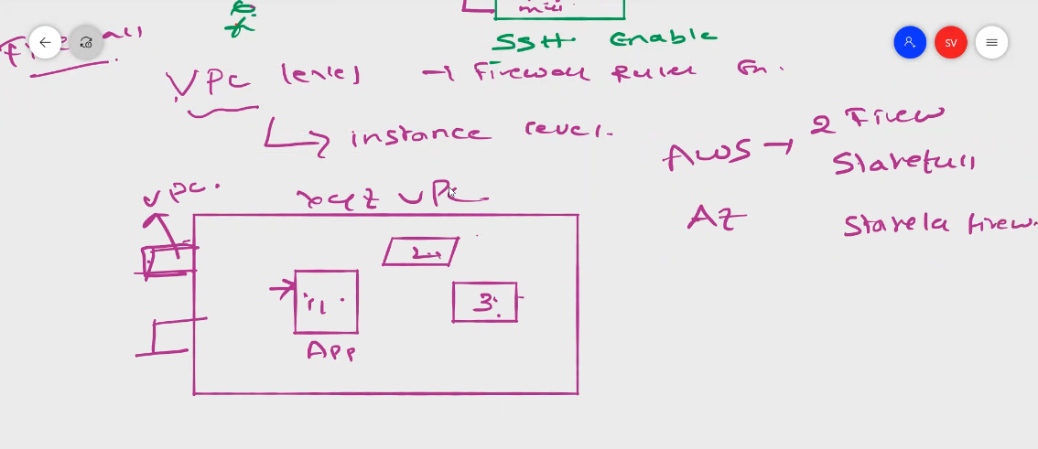

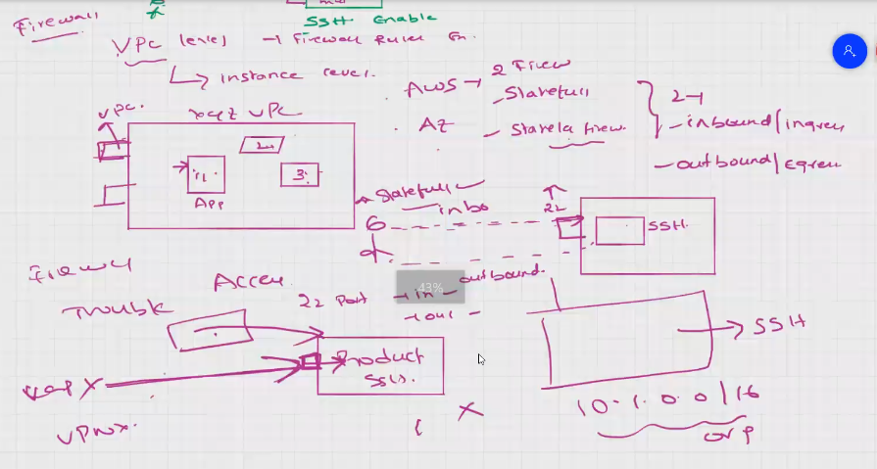

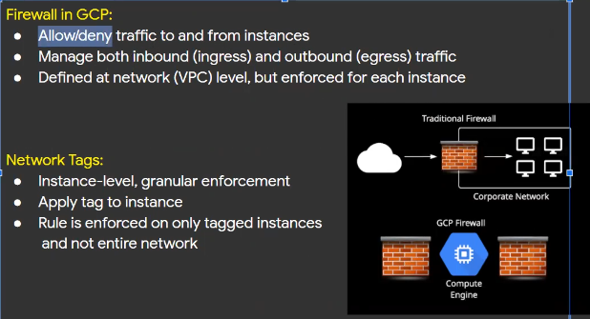

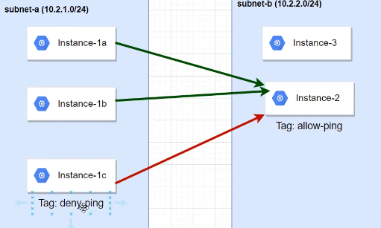

Shared VPC – organization level, org should be same

Standalone Projects – the project which is not using any shared vpc, default and custom vpc

Host Projects – projects hosted in shared vpc

Service Projects – projects which can consume the host projects vpc

Shared VPC or Cross Project Network – using shared vpc we can create

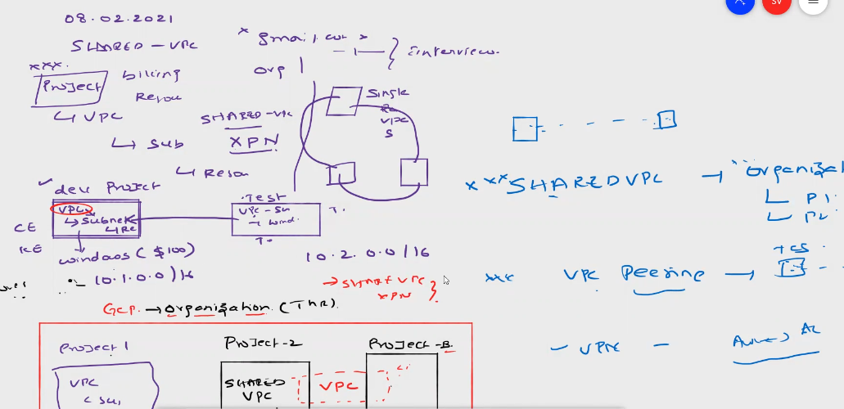

Network user’s role - organization level role – user should have their roles

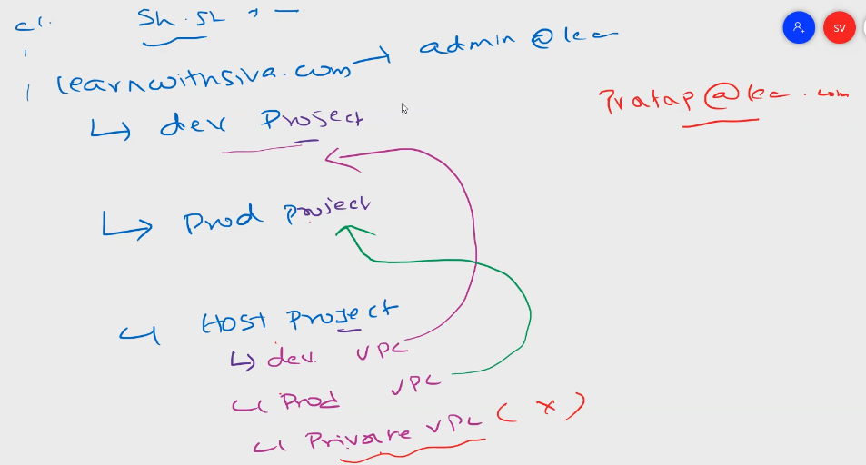

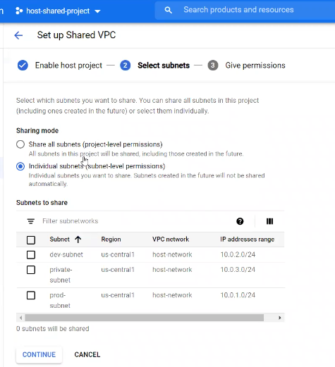

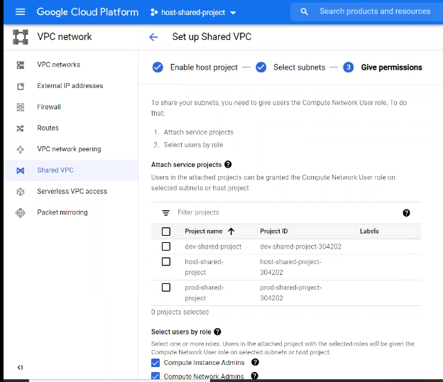

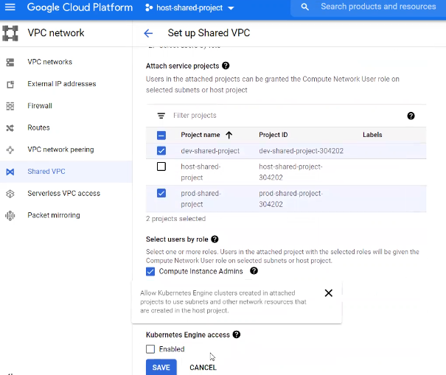

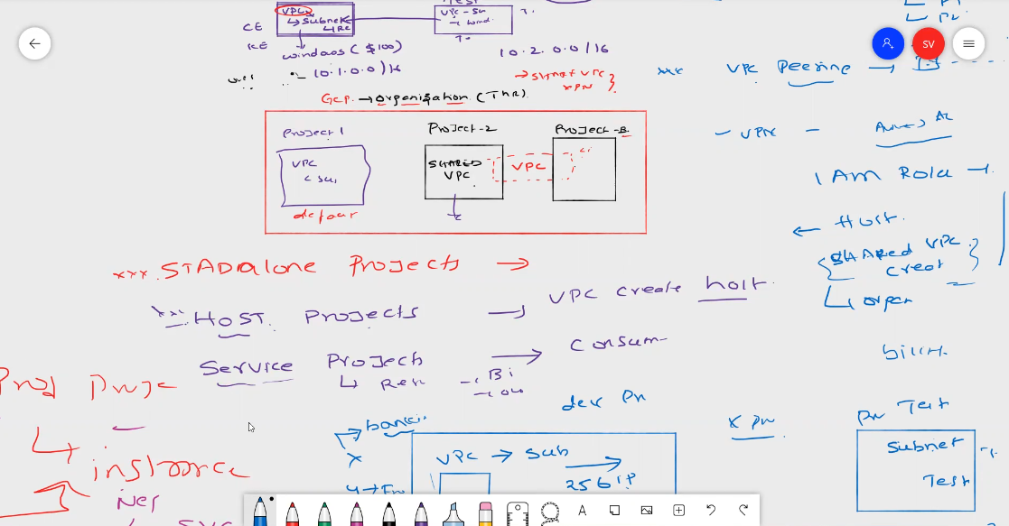

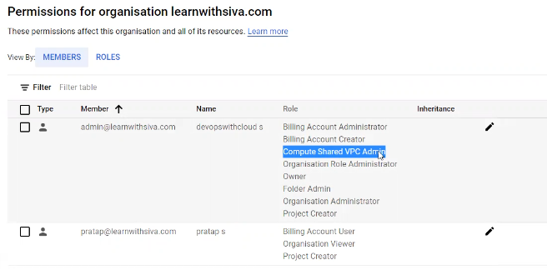

To create Shared VPC user should have Compute Shared VPC Admin role

To create Host Project

We cannot delete shared vpc connected projects, first we need to disable the shared vpc option for that project

Go to shared vpc enabled project and disable the project then delete

Host project cannot act as service project,

One host project is there, created another host project and can we give permission to access the subnets?

No, host project can access only as host project or service project but not to another host project

Host project is having 10 projects, to share we can share only some vpc to users to access, but not subnets in the host project

VPC Peering

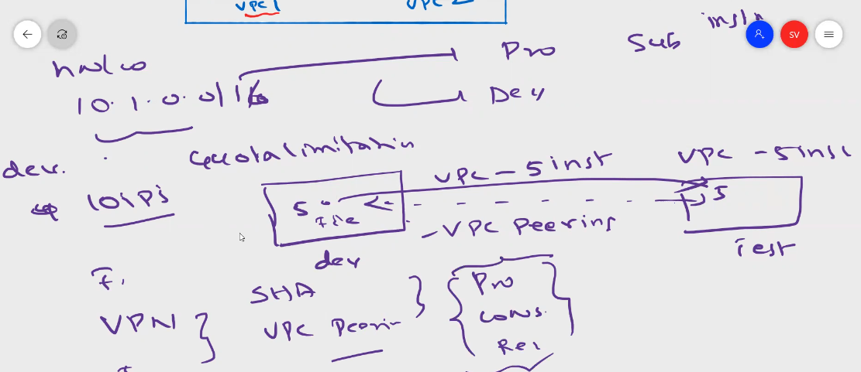

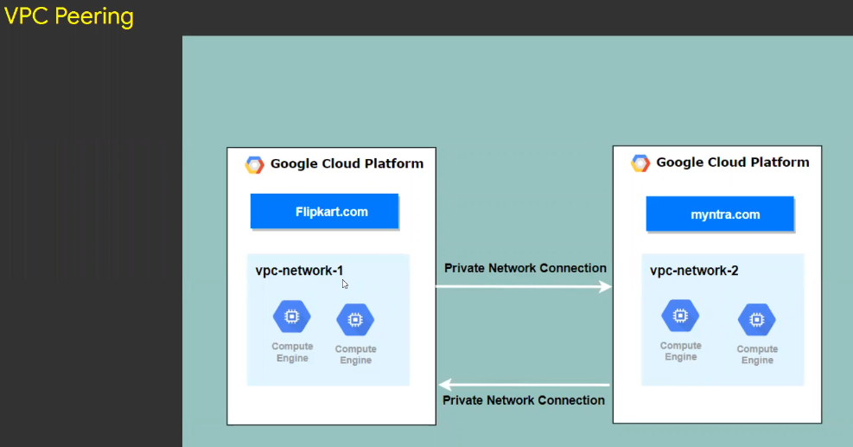

VPC peering advantages

1. Latency between vpc-peering
2. Security
3. Cost for vpn
4. Vpc peering setup is easier compared to vpn

Shared vpc, should be within the same organization

Vpc peering, can establish peering in same org, same project, different account, different org, but limitation, these vpc should be in GCP

To connect to multiple cloud providers we us vpn

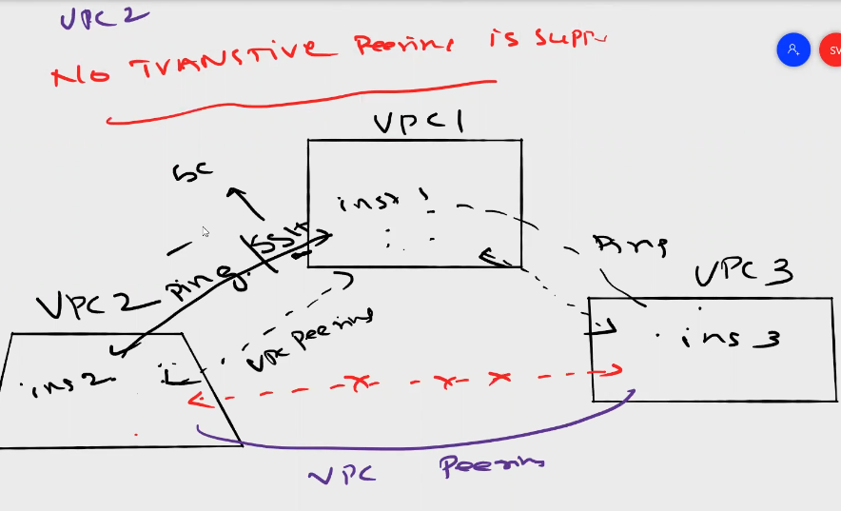

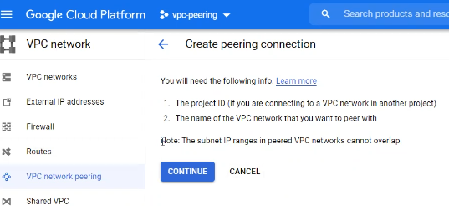

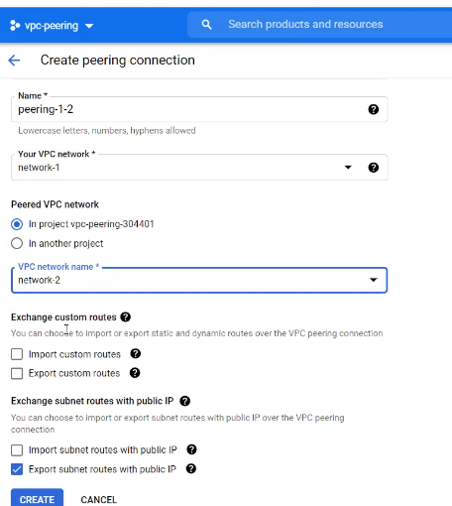

**Google compute Engine (GCE)**

Google first compute service is GAE (Google App Engine) – PAAS

Code only customer can manage, underlying infrastructure google manage

Infrastructure – os, apps

Platform – only code deployments

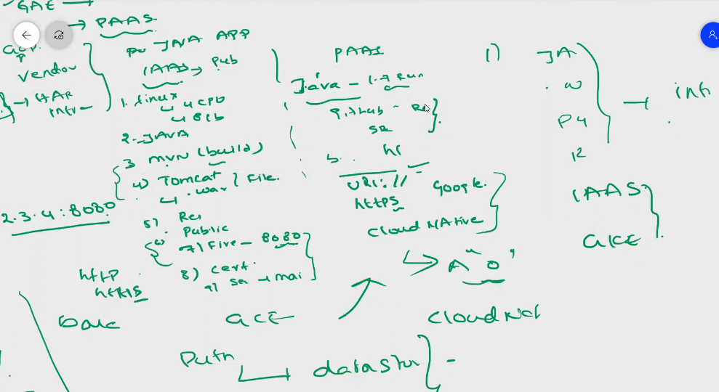

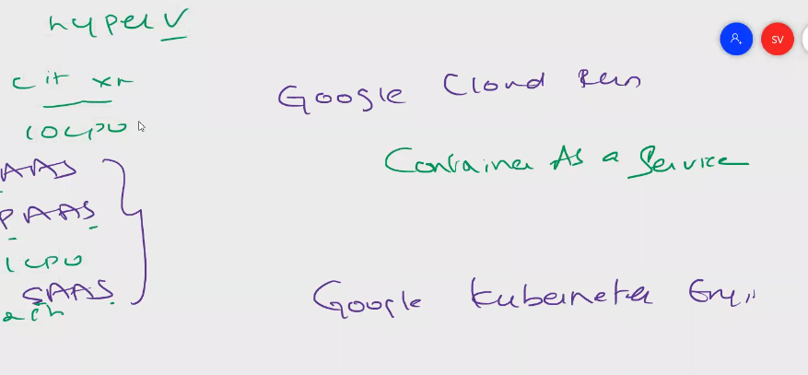

Vm instance name is permanent

Region and zone can’t be changed once instance is created

Instance size is e2 standard, e2 high cpu, and n1 standard

Can change cpu platform

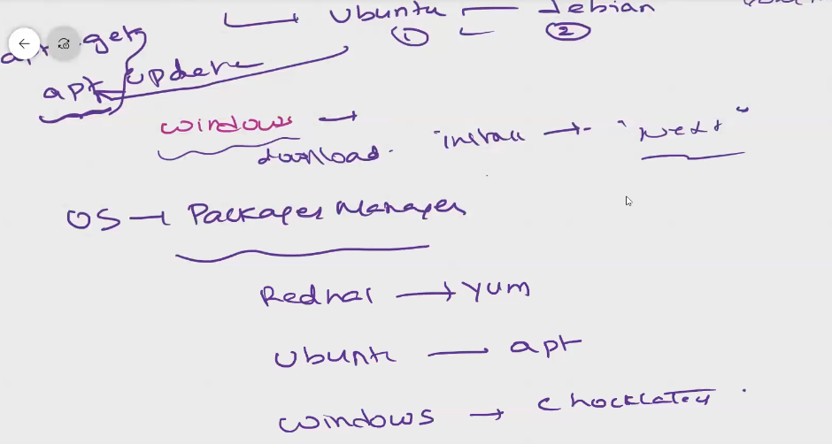

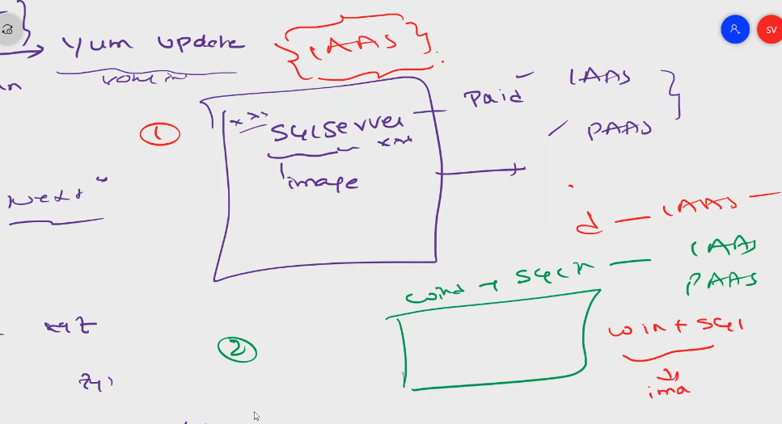

Ephermeral ips can be changed once vm is restarted

Ephermel ips are external ips

Should be none

Once public ips purchased we need to attach to instance, otherwise will be charged

To connect to the instance from cloud shell

Gcloud compute config set project project name

Gloud compute instance list

Gcloud compute ssh instance-2 –zone=eastus01

When you connect to vm, hostname to show vm name where you are

Gcloud auth login = to login as user account

Keys are google managed keys

User managed keys

To connect to ssh from local machine

Ls – la = hidden files

To list the ssh keys

Gcloud compute instances list

To login to the project

Gcloud config set project project name

Once go to project, to list instances

Gcloud compute instances list

Rm google_compute_engine to remove the keys

Ls –la

Watch

Gcloud compute ssh instance1 ==zone us-central1

Cat known_hosts

To generate ssh keys

Ssh-keygen –t rsa –f gcp_keys –C sivagcp

Ssh-keygen –t rsa –f c:/users/profile/.ssh folder

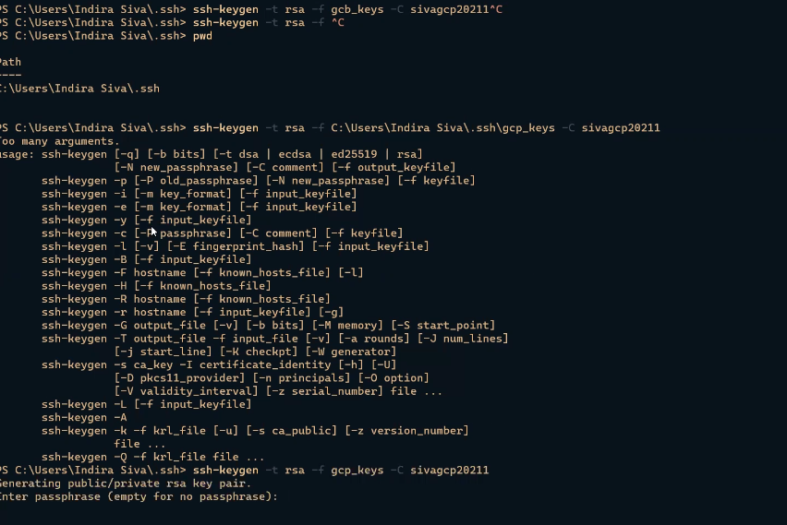

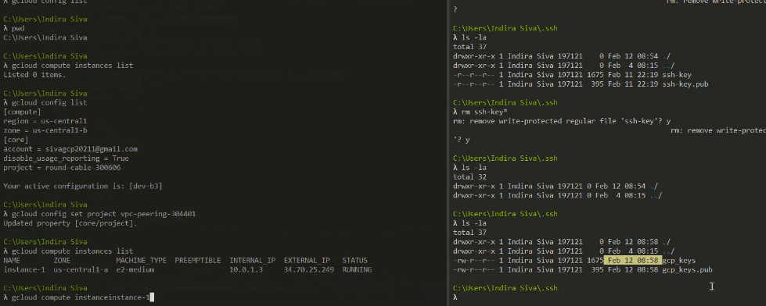

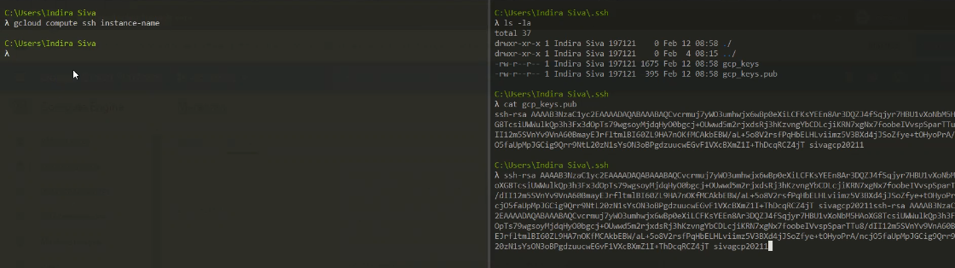

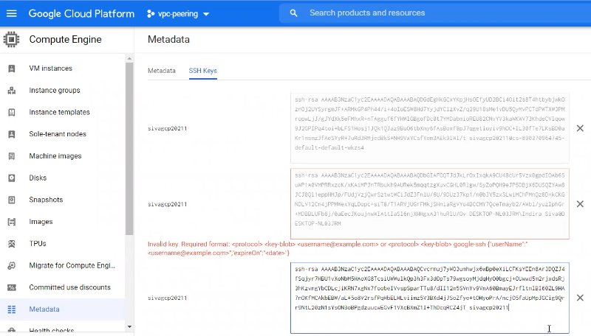

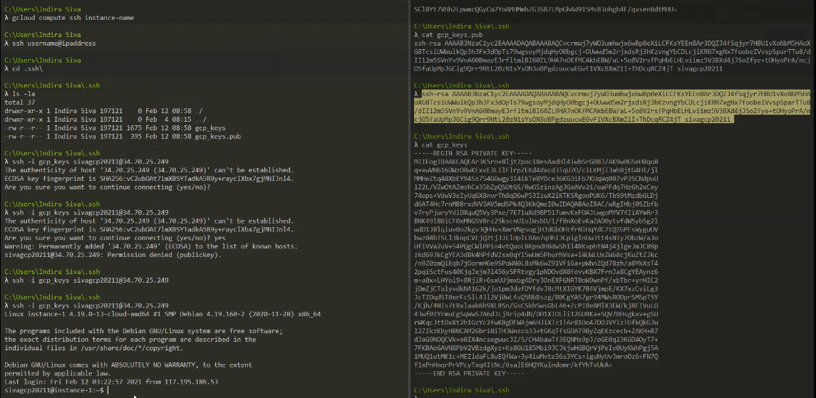

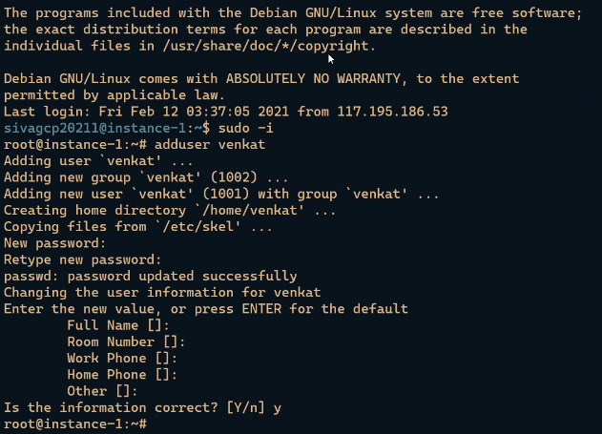

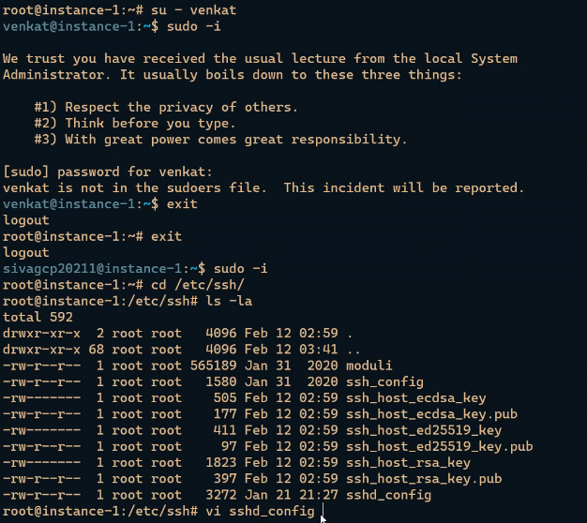

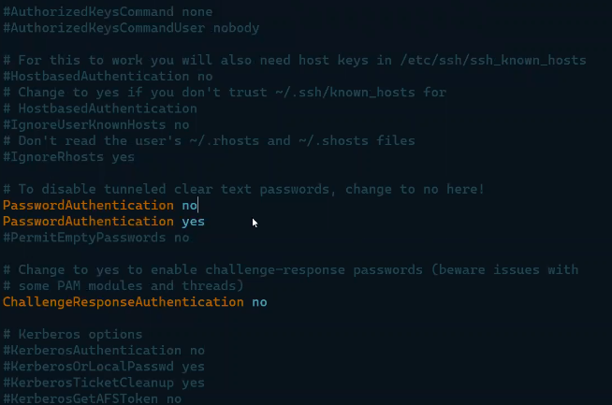

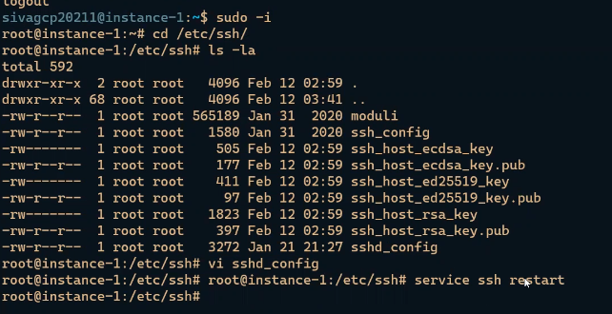

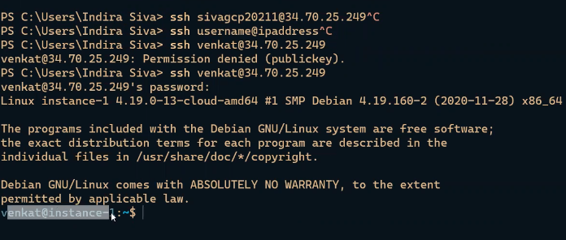

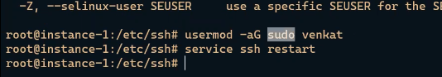

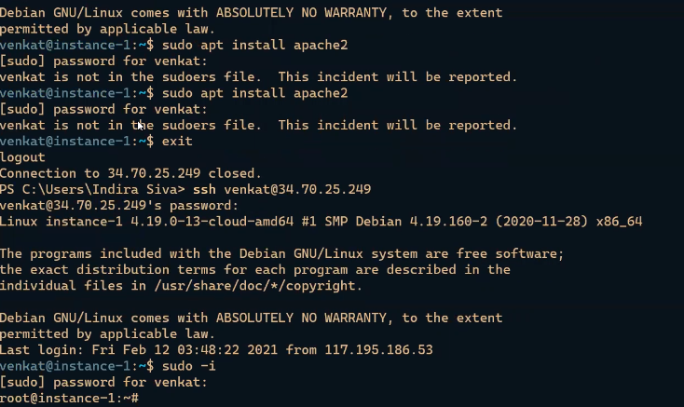

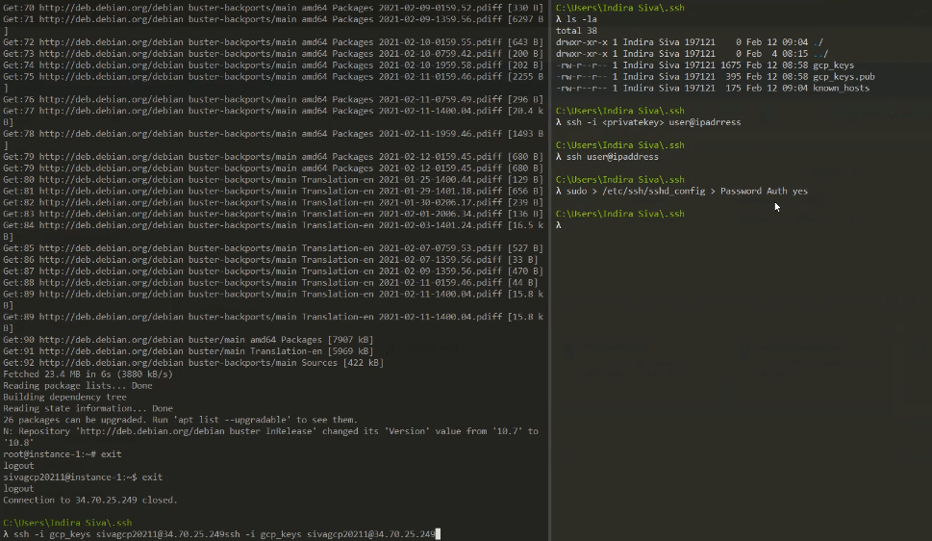

Disks

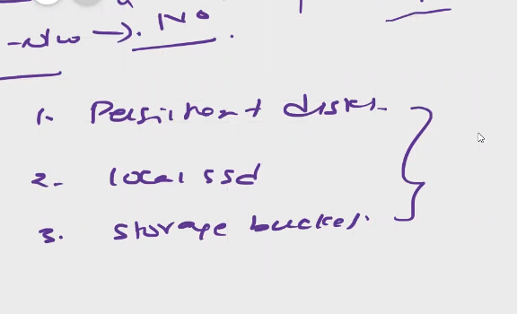

Disks are 3 types

1. Persistent disks
2. Local SSD
3. Storage buckets

Checking and mounting disks in linux

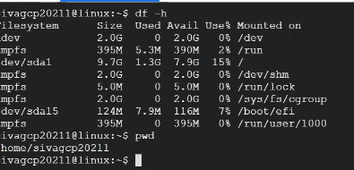

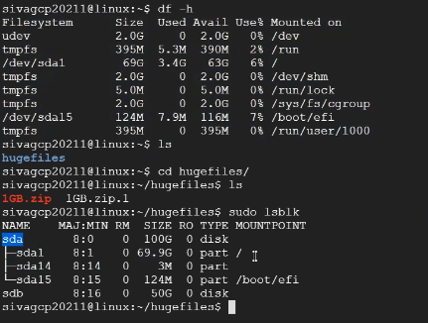

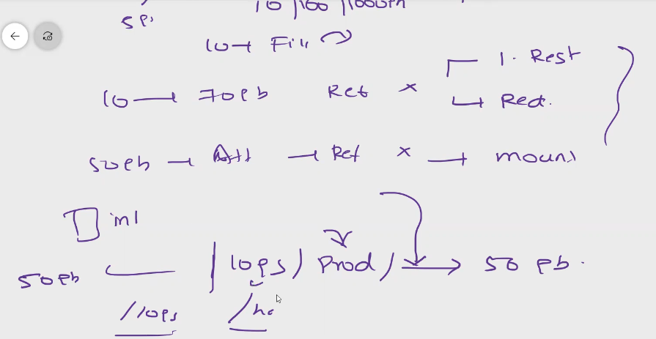

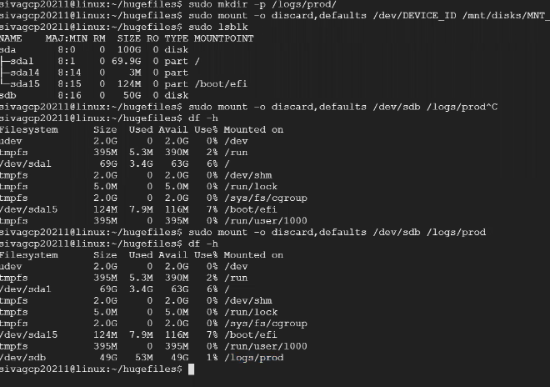

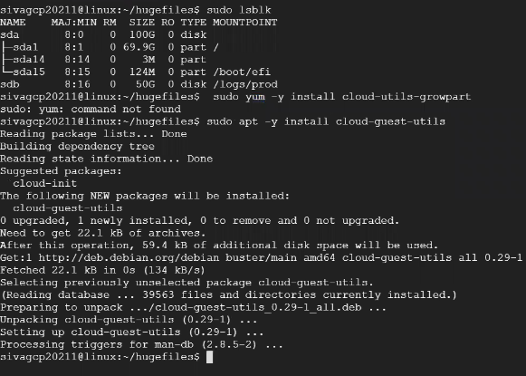

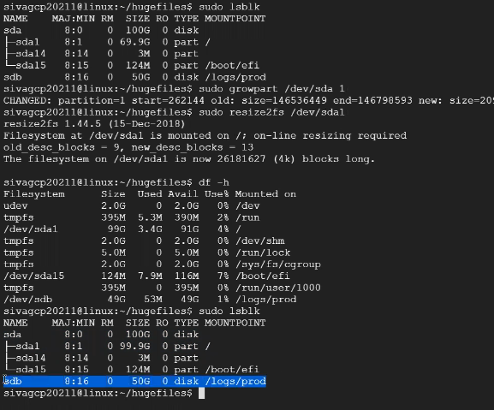

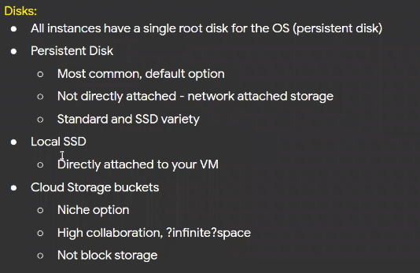

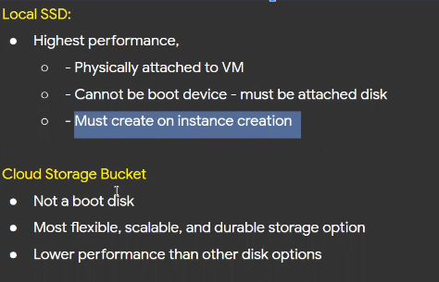

**Packer Tool**

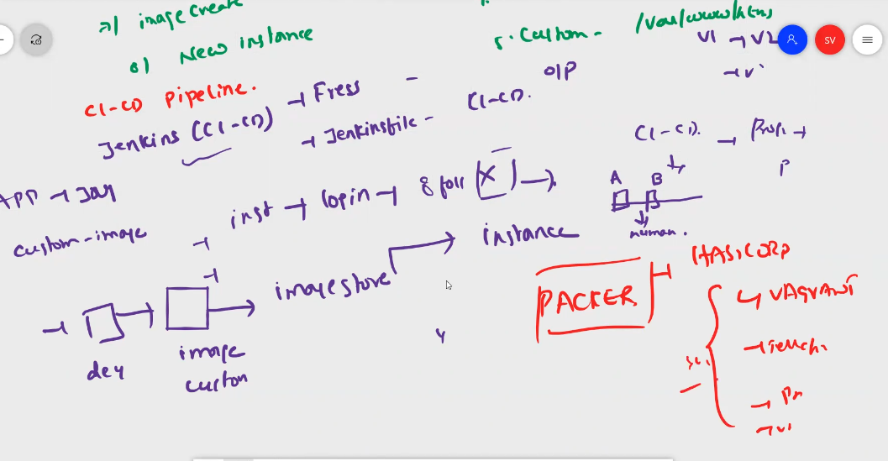

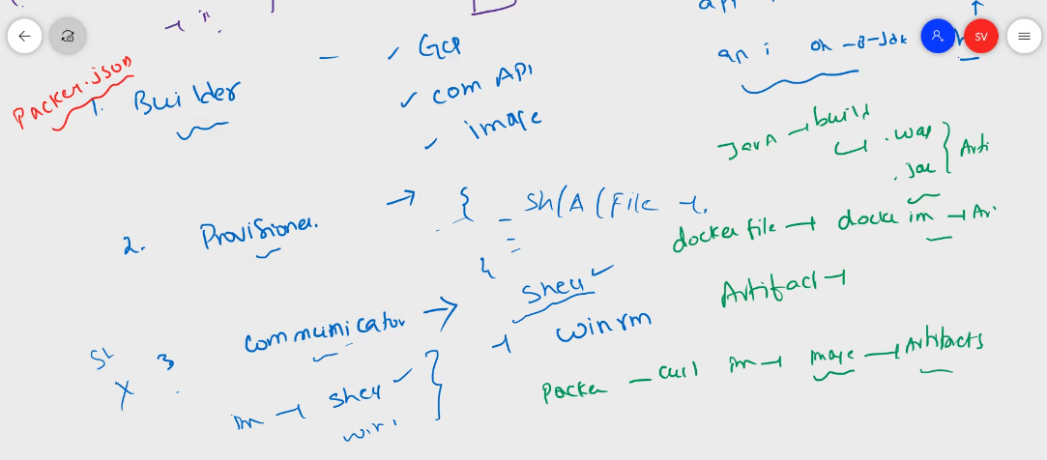

Download packer software from the below website

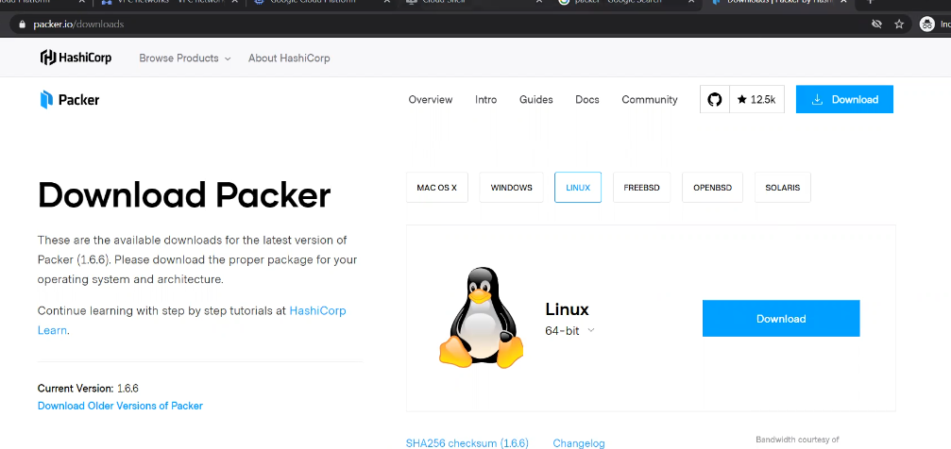

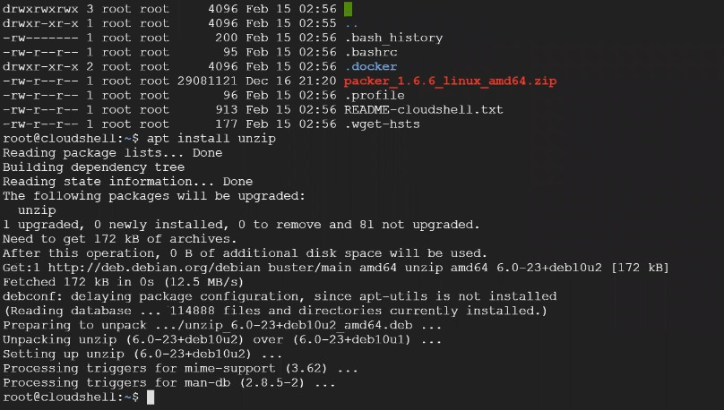

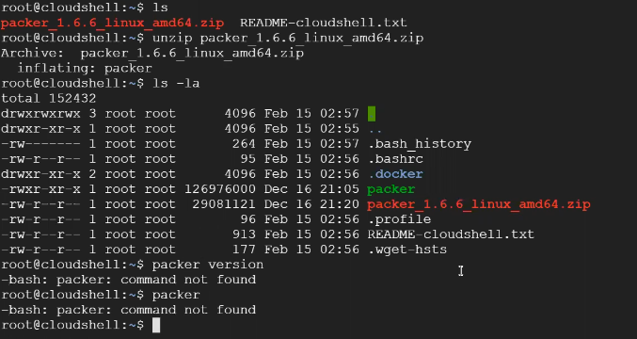

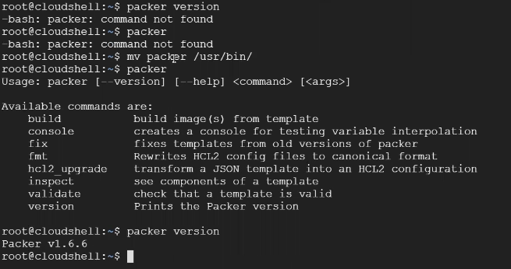

Then install required software and to make the image

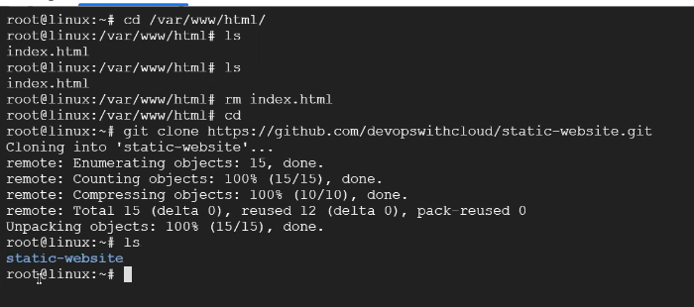

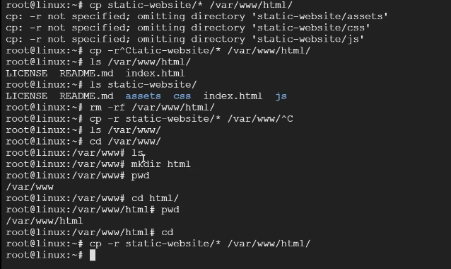

To make image we need to write .json script

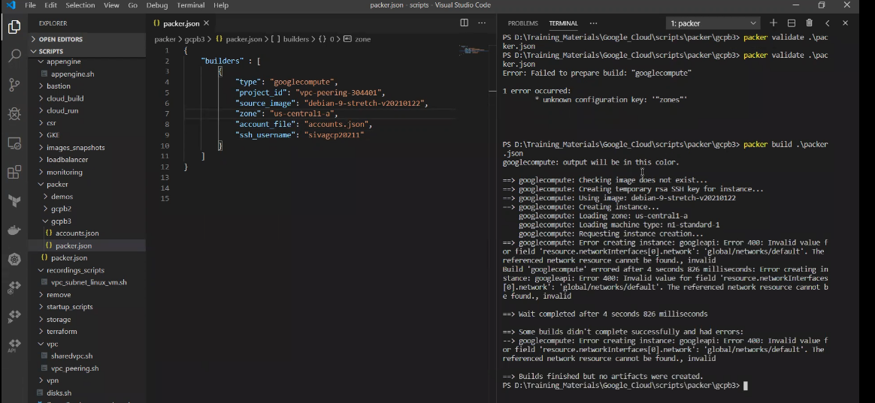

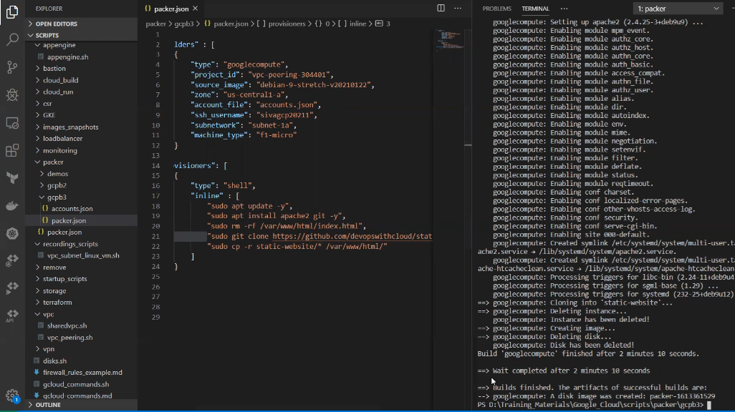

Image creation steps that script performs

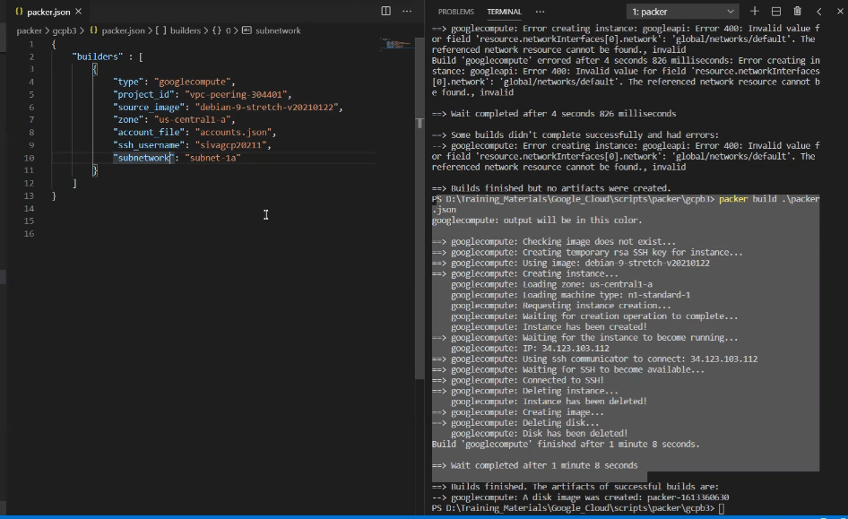

Hashi corp introduced HCL for packer and make images

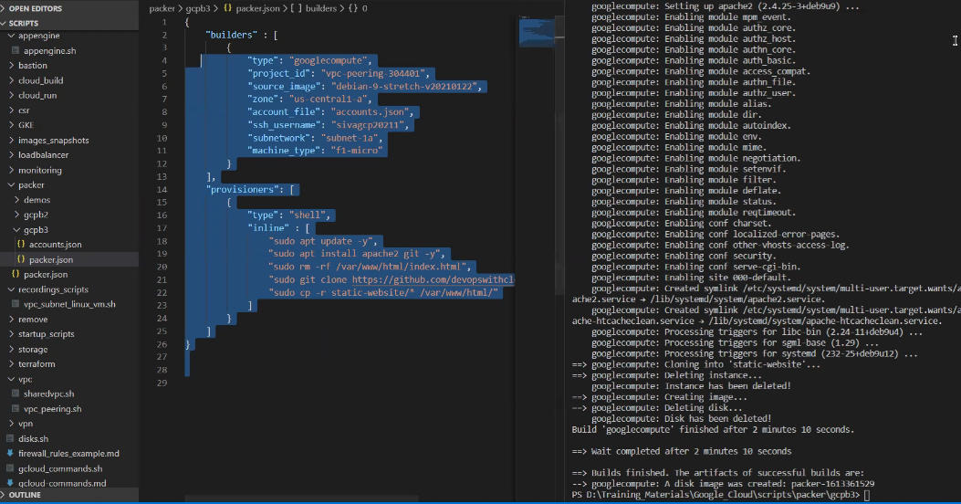

Packer image flow

Creates vm, then delete vm, from vm disk it creates the image, from those images create vms as per the requirement

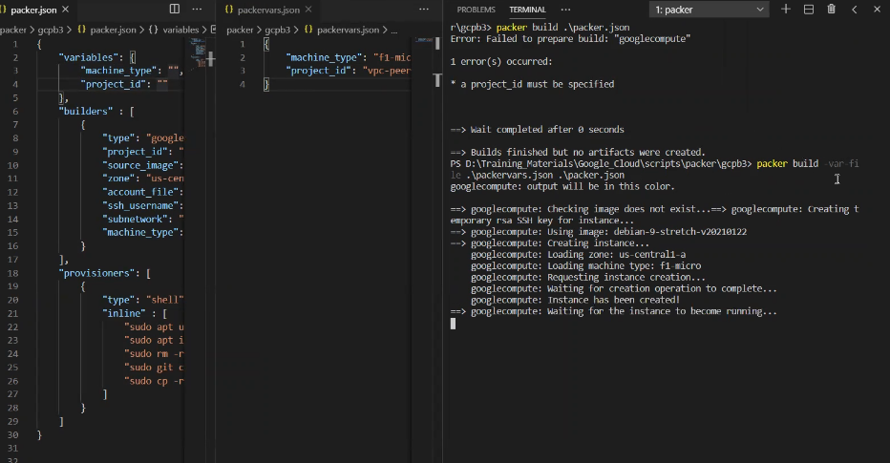

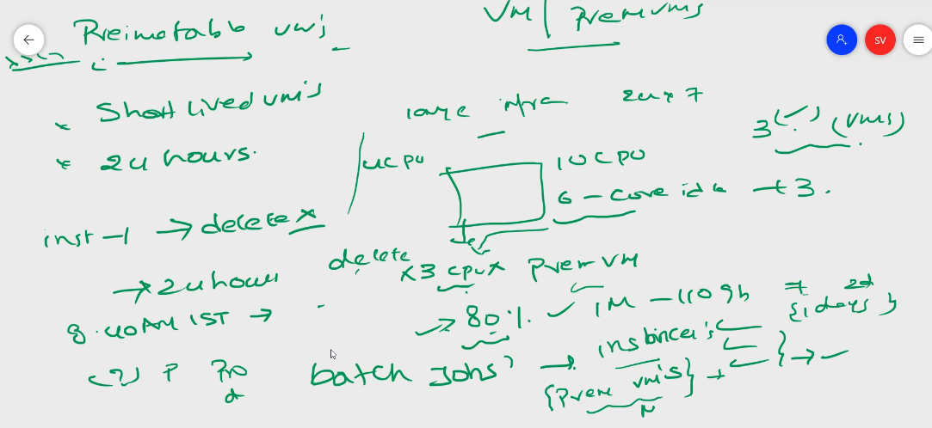

Premitable vm are used for batch jobs and transaction jobs

Not for production

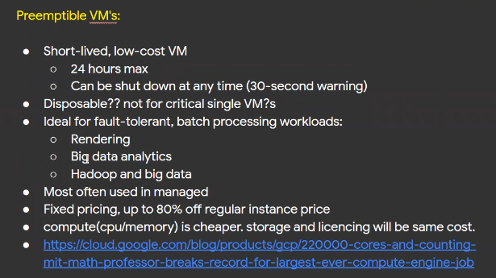

Bastion host

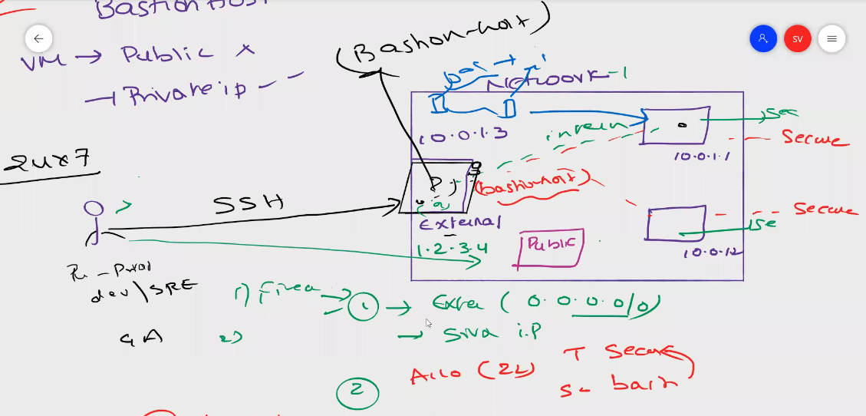

Instance Groups

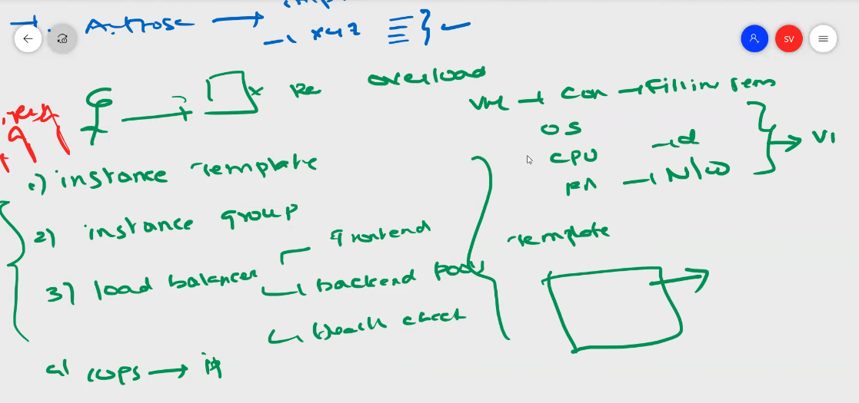

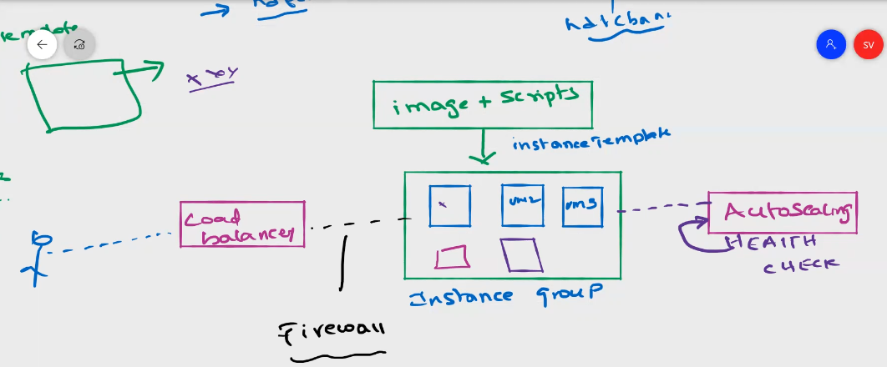

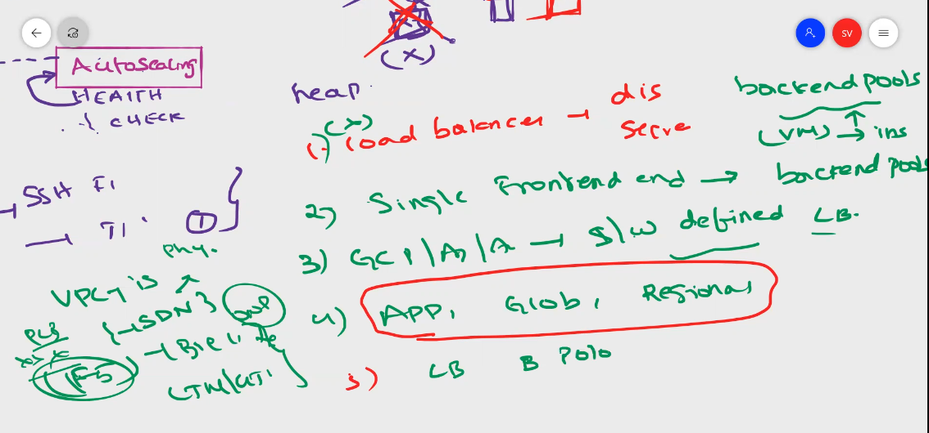

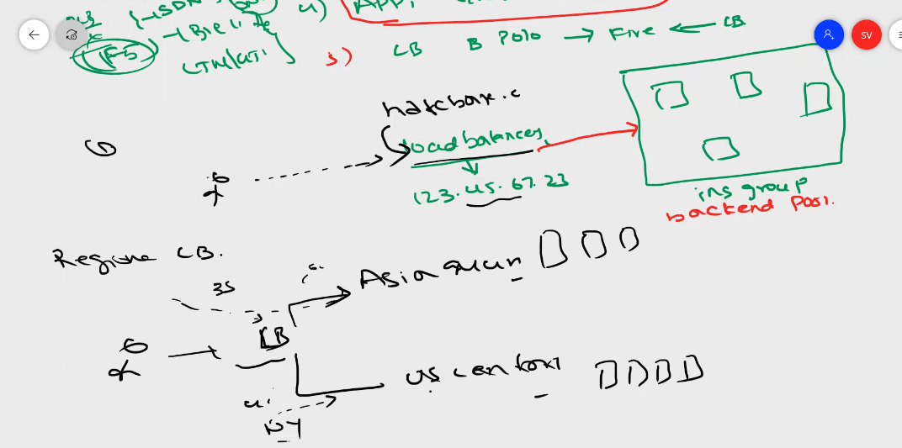

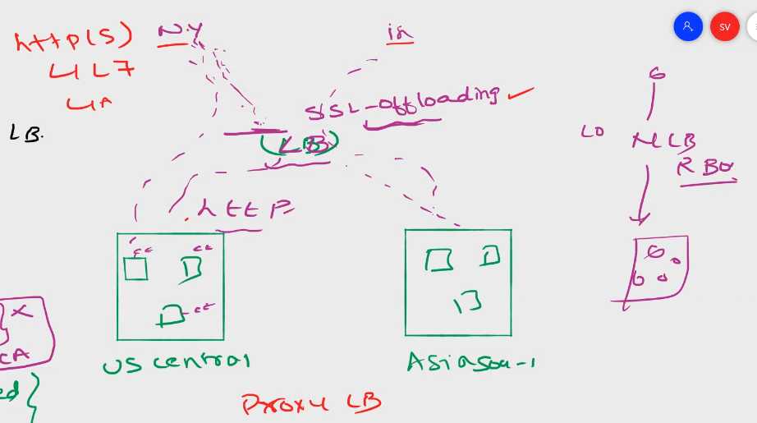

Layer 7 loadbalancer

For traffic identifier is session affinity

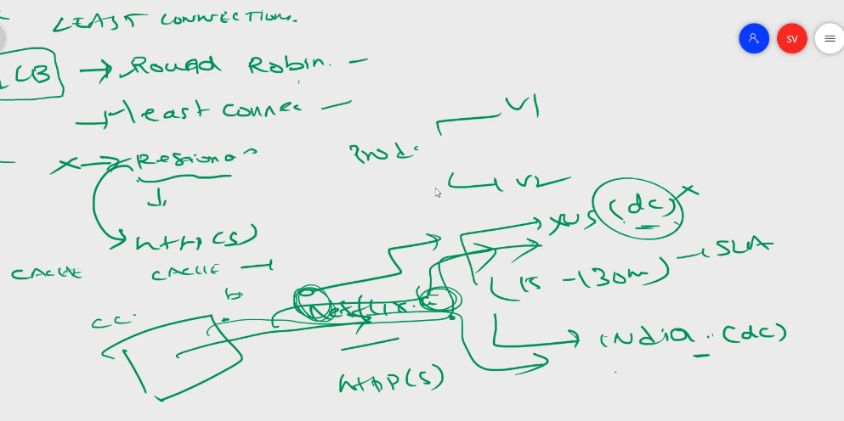

Health checks should be enabled for auto scaling

To create instance template

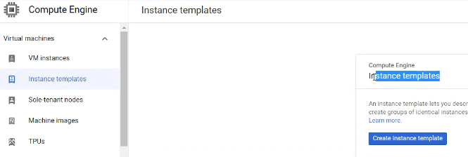

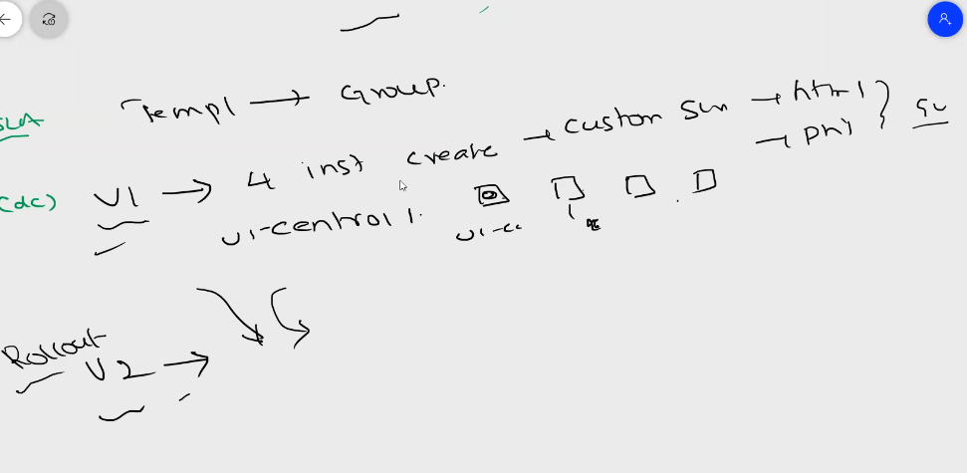

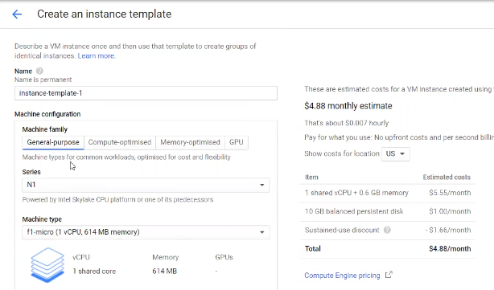

No need to specity zone or region for templates, only when creating instances from templete need to specify

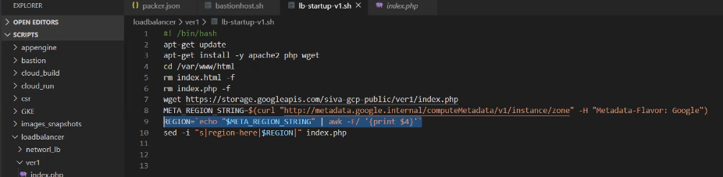

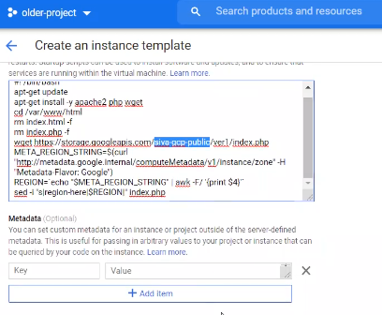

Creating the template with necessary scripts

Once created template, go to instance group,

Can configure instance group in single or multizone

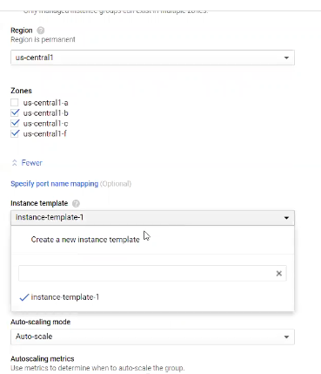

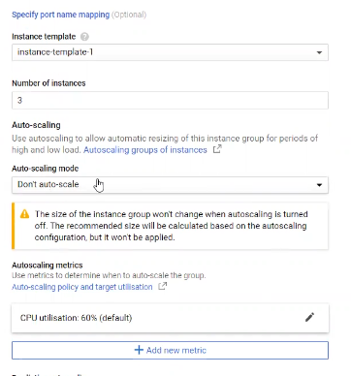

Create health checks for instance group

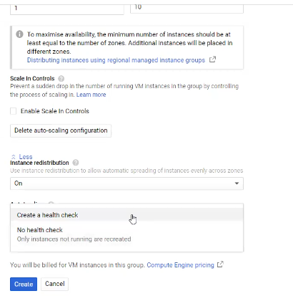

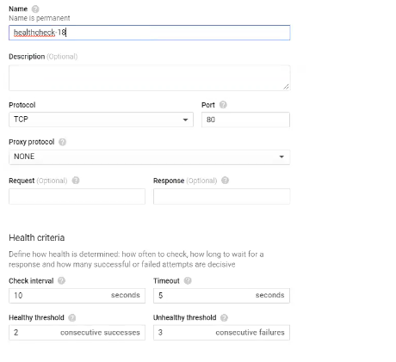

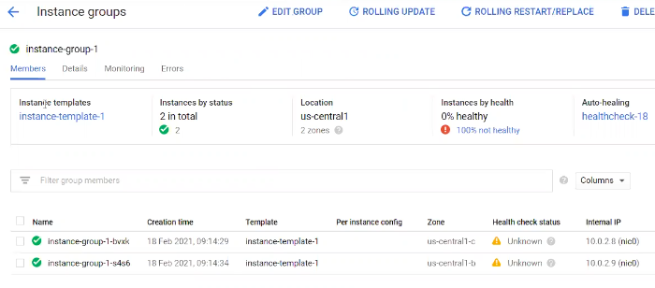

To delete the vm in instance group, its not allowed and have to delete entire instance group

For roll back or new version of application, create another template v2, and got to roll back and then below screen for segregate the traffic between different vms

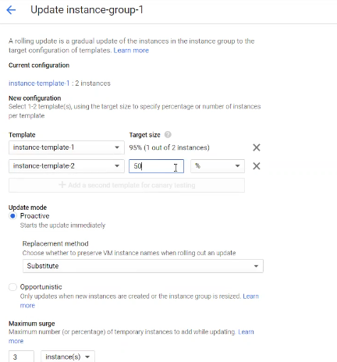

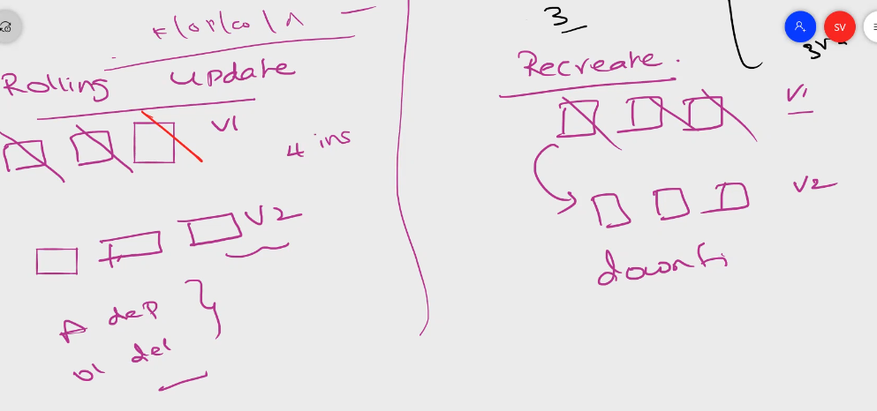

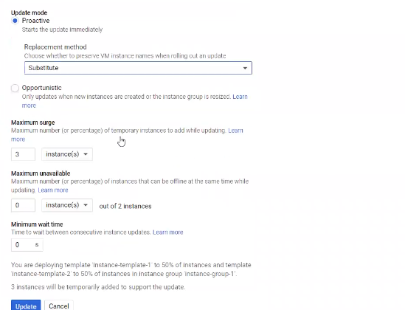

Load Balancers

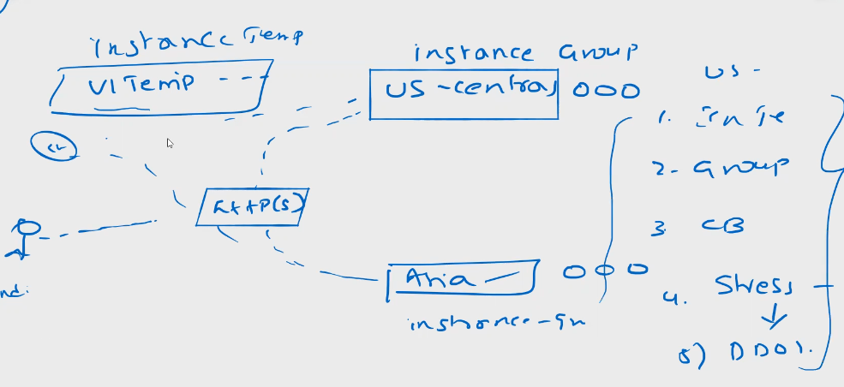

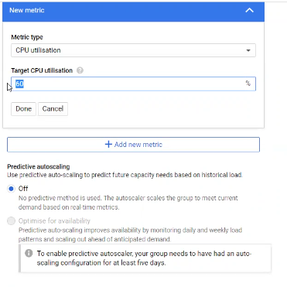

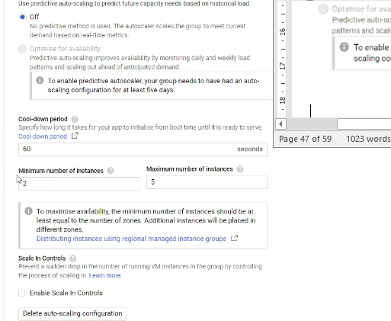

Load balancer

Frontend

Backend load balancers

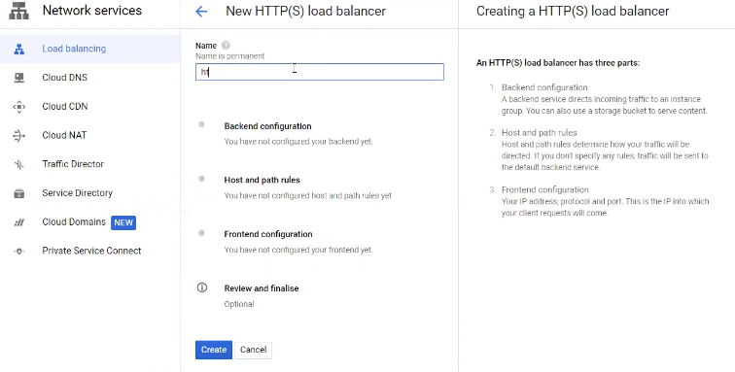

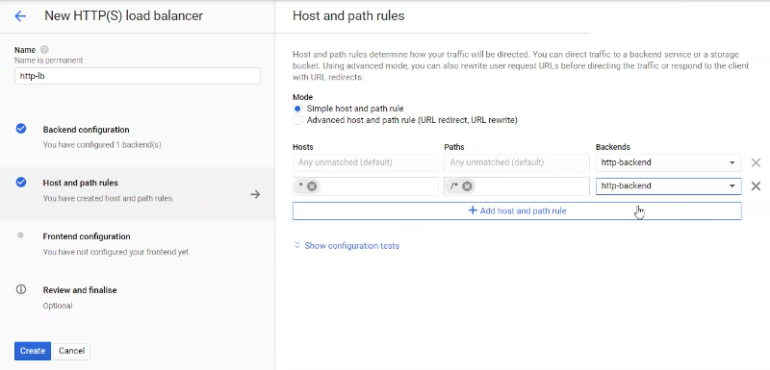

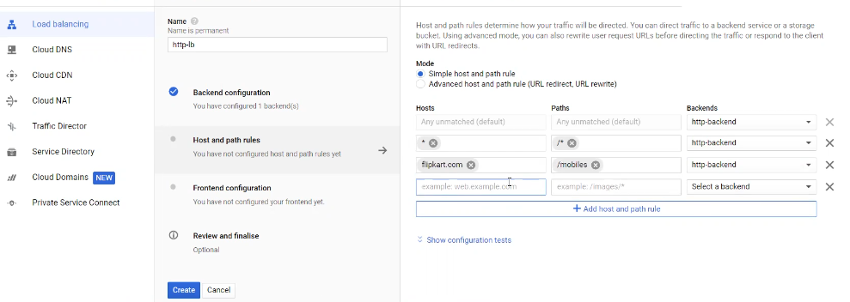

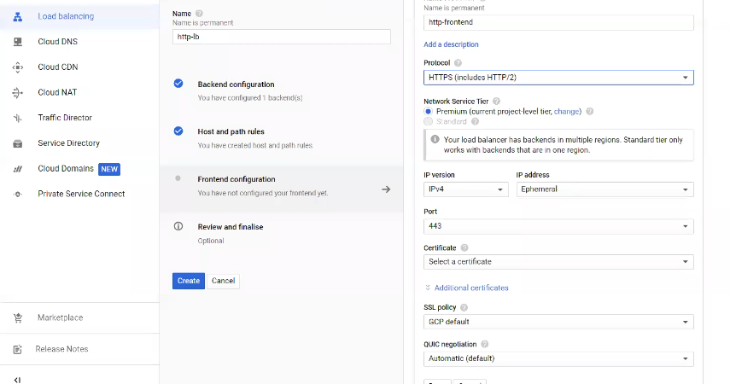

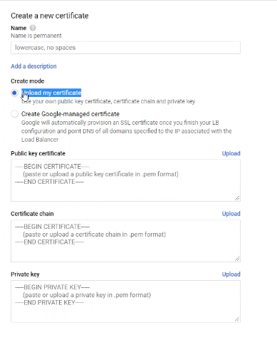

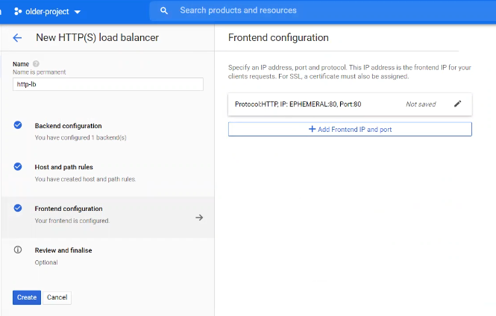

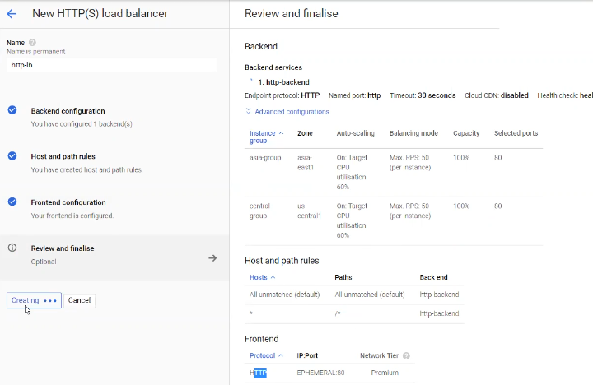

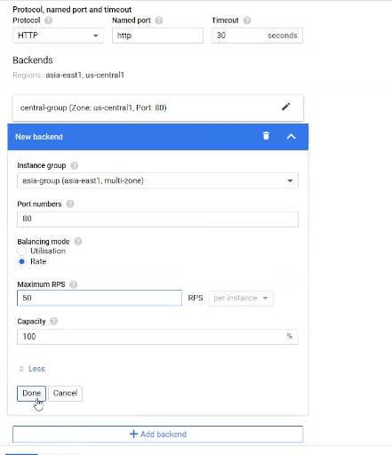

For load balancing we need to create multiple backends, in instance groups

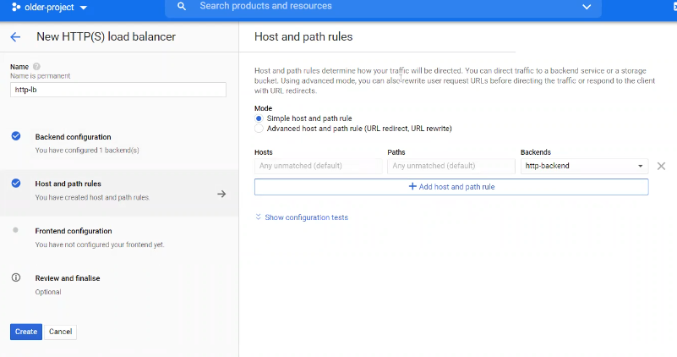

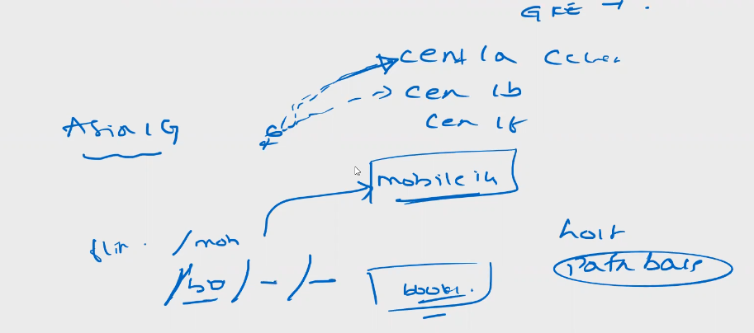

Host path based routing the traffic

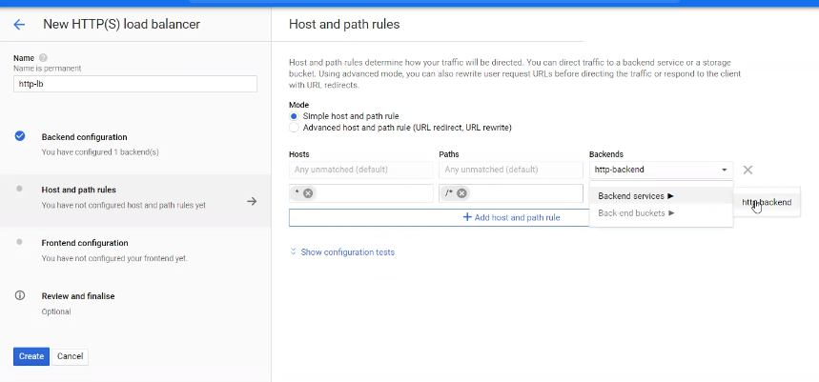

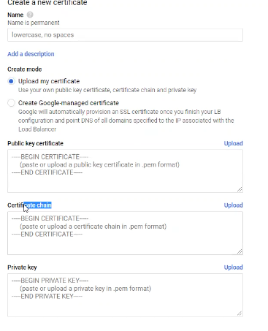

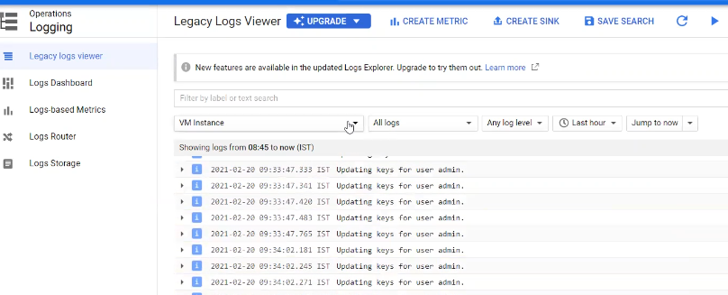

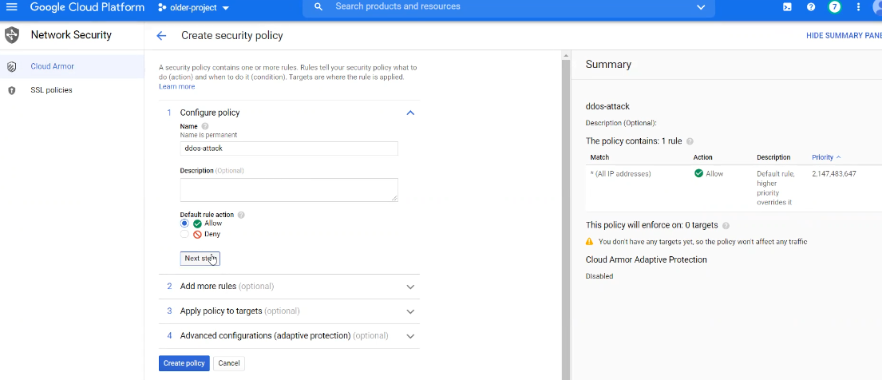

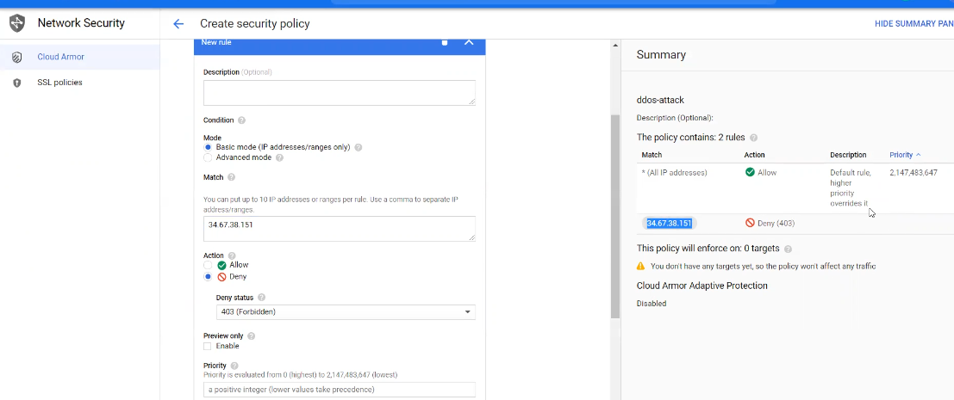

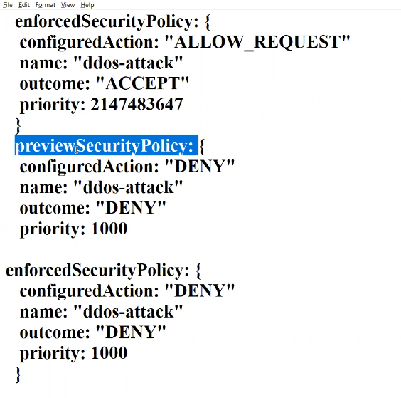

Hybrid Network

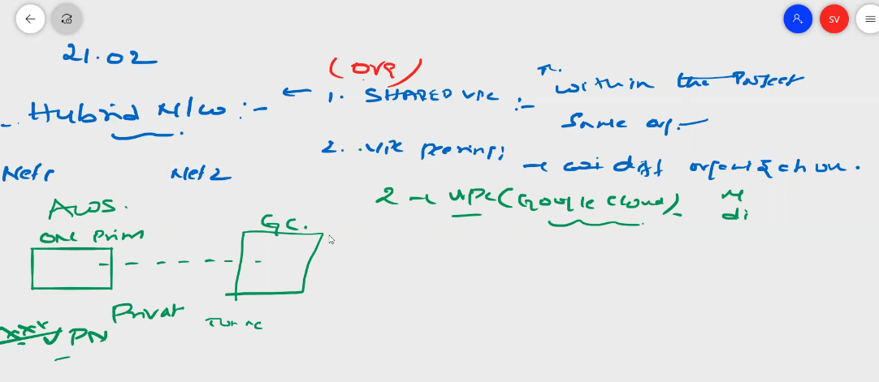

Connecting one or more networks is called hybrid network

3 types

1. Cloud vpn – on premises to google network, using tunnel, security encrypted

Onprimeses to gcp, vpn gateways, public vpn, tunnelling need to create

1. Static Route
2. Dynamic route

This is only site to site vpn

Not site to client vpn

Google support site to site

No region concerns, used for low volume of transfers

For heavy transfers cloud vpn is not suggestable

1. Cloud internet – dedicated physical connection, to gcp vpc
2. Cloud peering – dedicated network connect to google network

Aws – atnt provider

Azure - express route

1. Static vpn

Need to create vpn gateways between onprime and gcp networks

Routing table connects the vpn engpoints

Need to create tunniling to connect

Static vpn does not support more subnets once created

If we want to create we need to establish static vpn again with newly created subnets

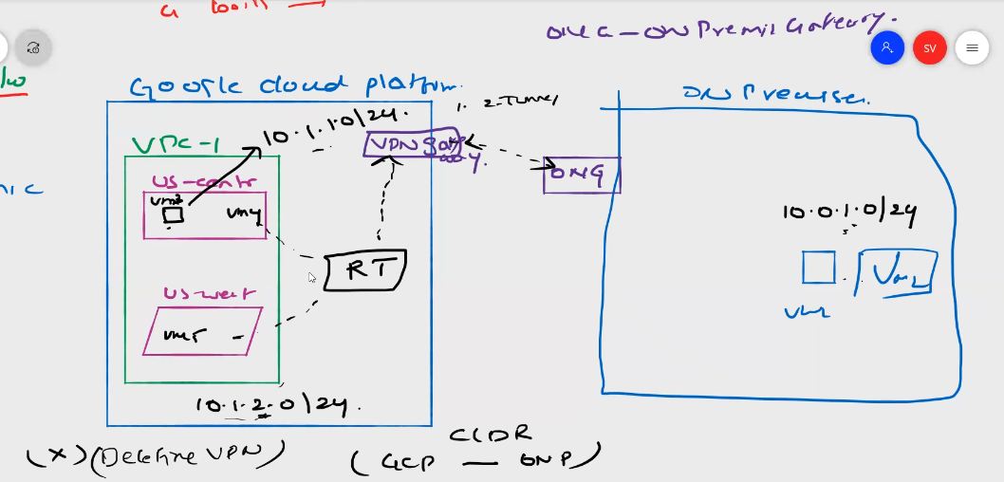

Dynamic vpn

In dynamic vpn, vpn connects through routing table to cloud route then vpn gateway then bgp protocol then onprime gateways and network

Bgp protocol takes care of vpn connection

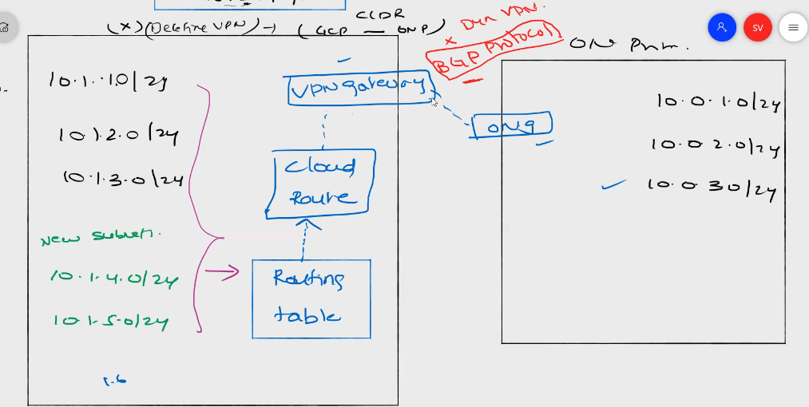

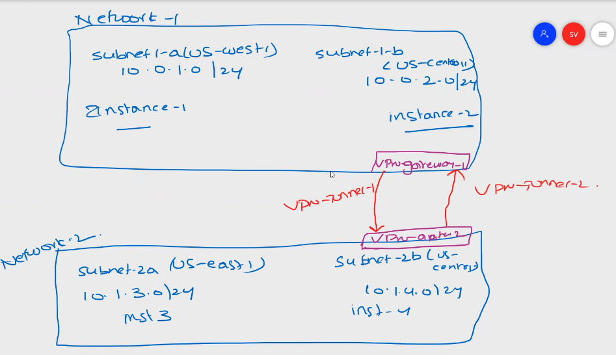

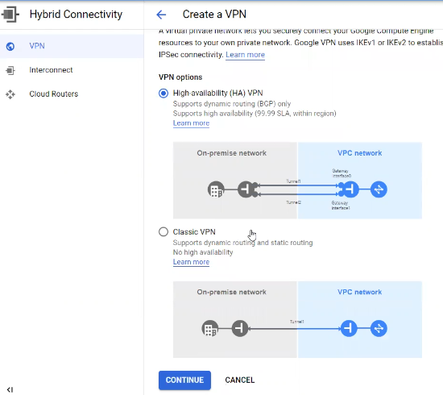

Vpns are two types

1. High availability
2. Classic vpn

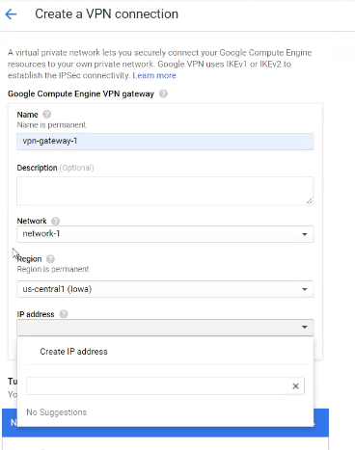

Google vpn uses IKEv1 or IKEv2 to establish the ipsec connectivity

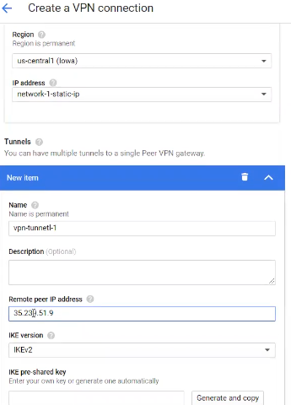

And need to provide network 2 static ip

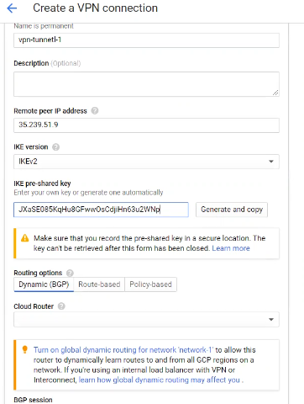

Copy generated token to enter it in network 2 token for authentication

Dynamic BGP, Route-based and policy-based routing

For static we use route based routing and provide network 2 subnets for communication

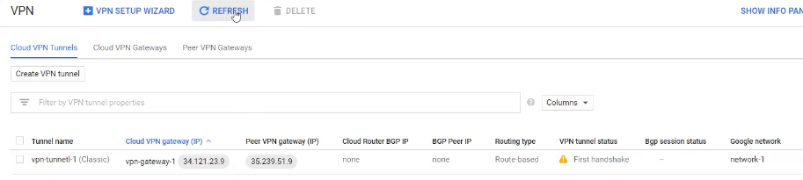

Establishing vpn from network 1 to network 2 (ex. On premises)

Repeat the same process to establish vpn connect from network 2 to 1, for pairing the vpn

And check if both networks are connection and established

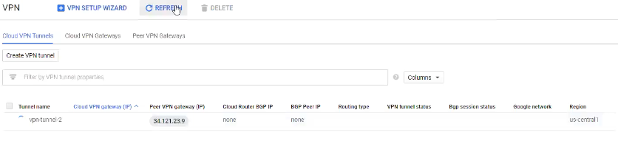

In dynamic vpn setup, we need to assign autonomous system number (ASN)

For peering

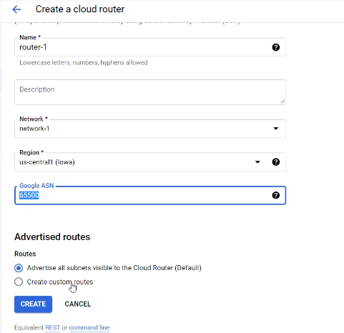

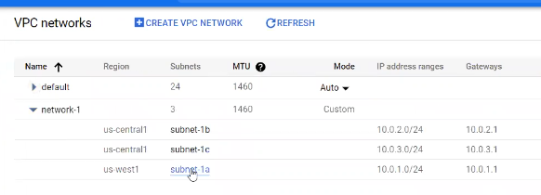

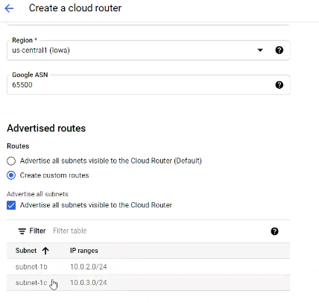

To expose all subnets, need to change VPC network from regional and global in vpc settings, click on vpn and edit and change it to global and save

Then again create cloud router to apply changes to create dynamic vpn, then select advertise subnets visible to the cloud router

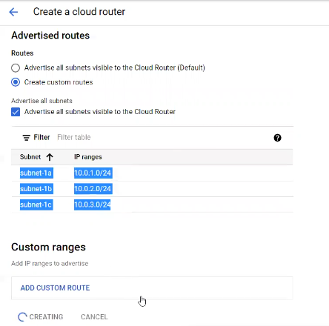

Network 2 settings below

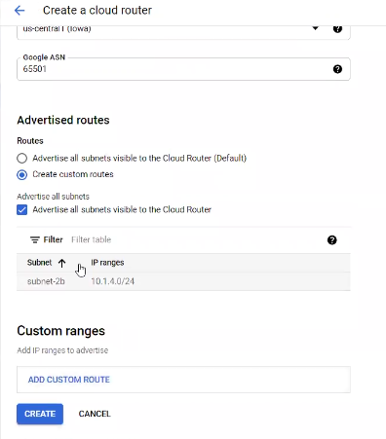

Then create vpn gateway and connect cloud router, and then provide ASN number in bgp configuration, provide port number 65501

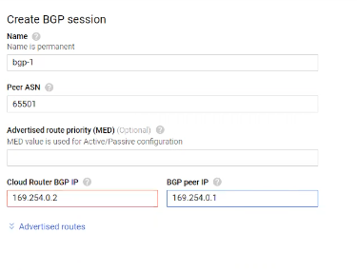

Asn number range 64512 to 65534

Storage

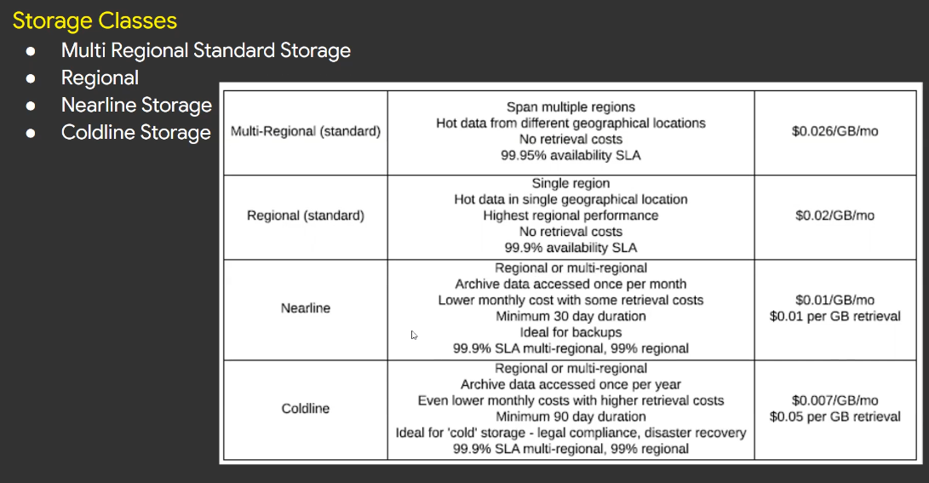

Cloud dns is the highest sla in google cloud services

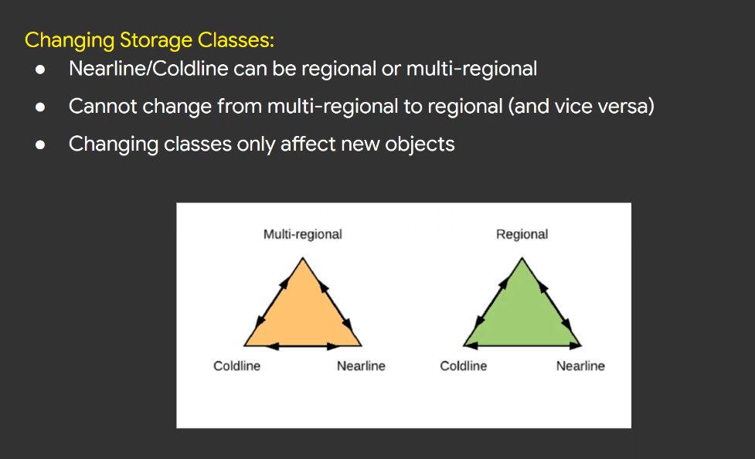

S3 bucket

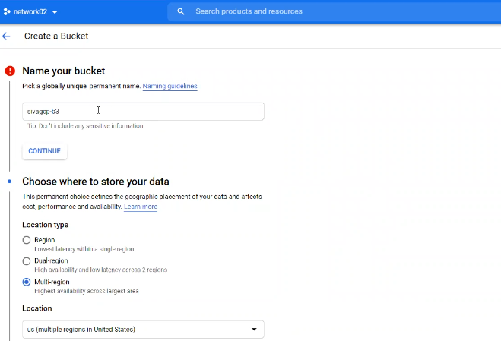

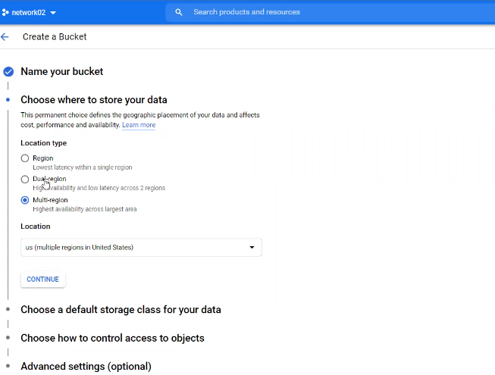

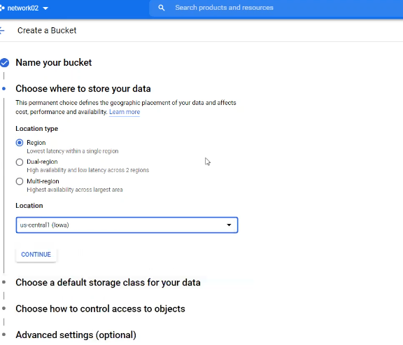

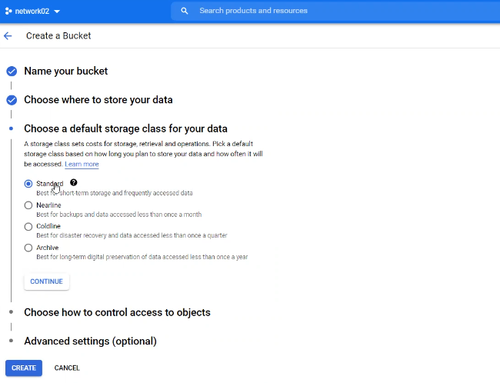

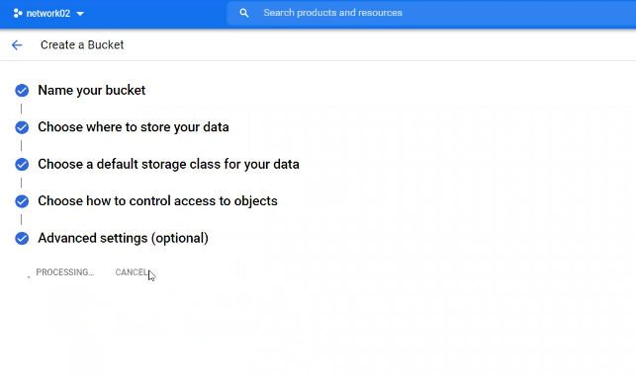

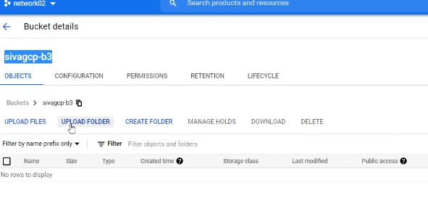

By default google buckets are not public

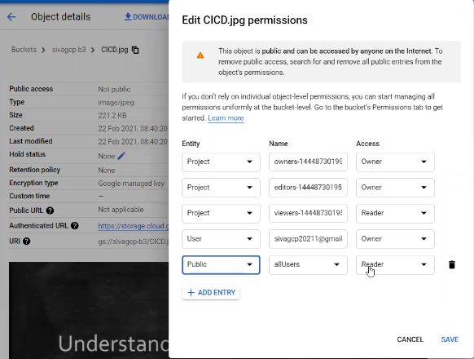

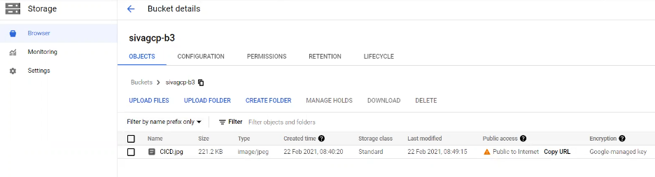

To create storage bucker using command line or cloud shell



To list buckerts

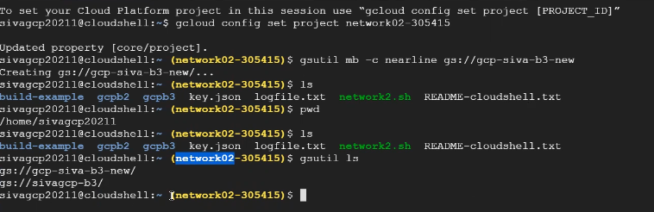

To list the files in bucket

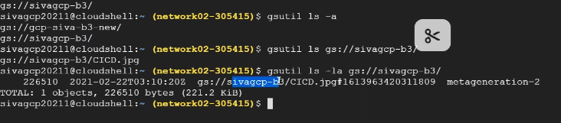

Generation ID in above screenshot

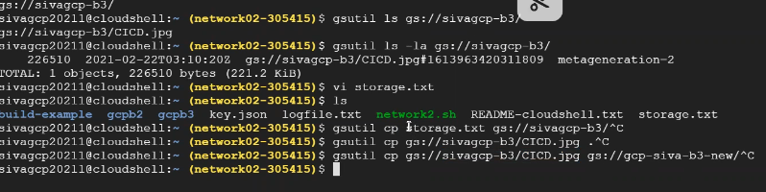

Creating file versioning to bucket

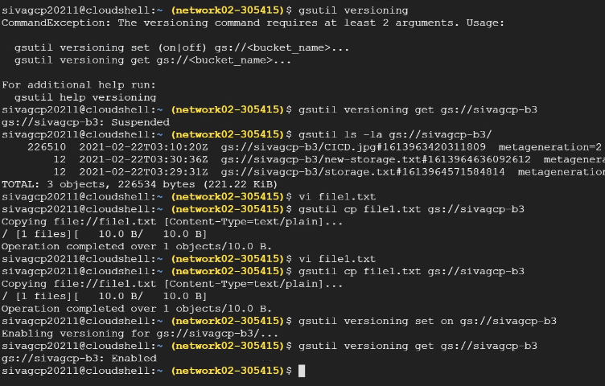

We can see changed version of file using only command line

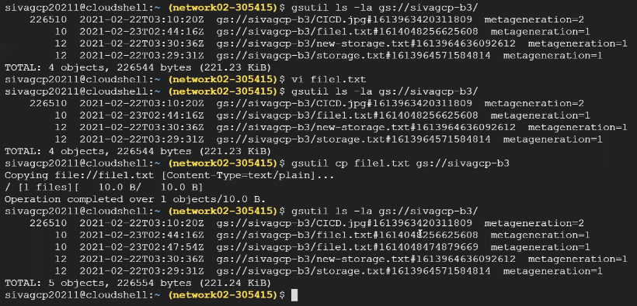

To go to previous version of file

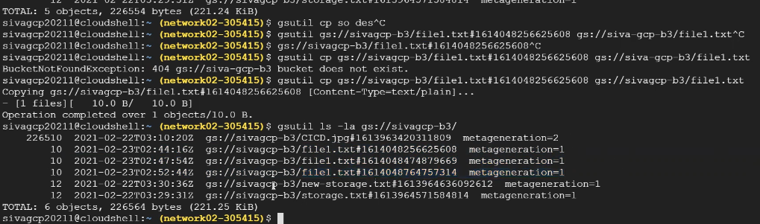

We can retrieve deleted files from the version enabled buckets from console only

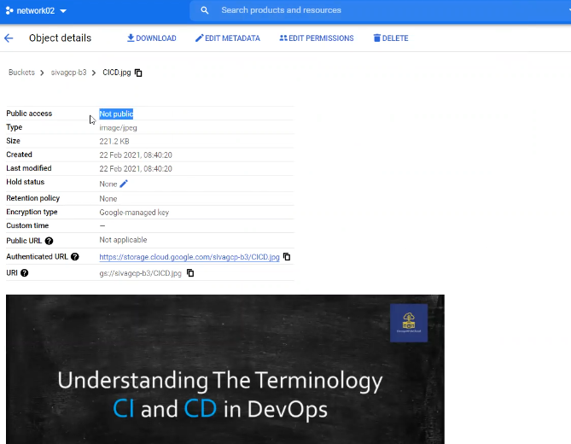

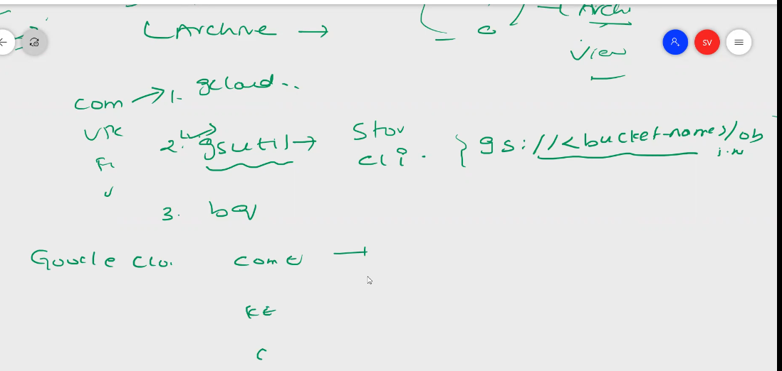

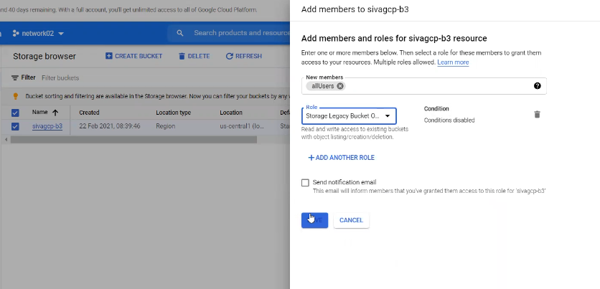

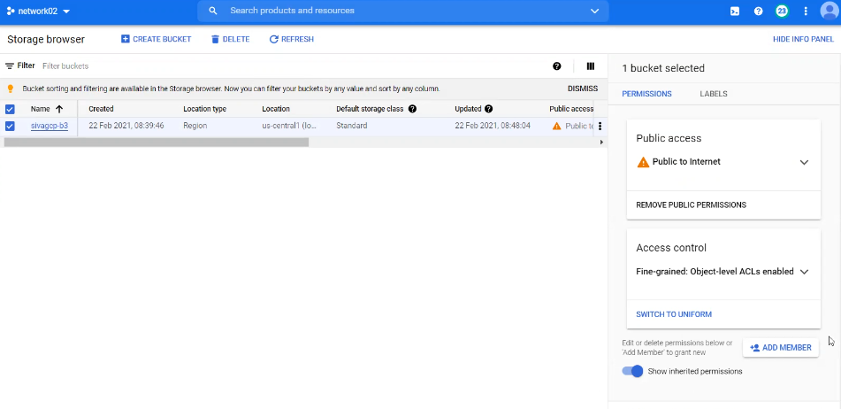

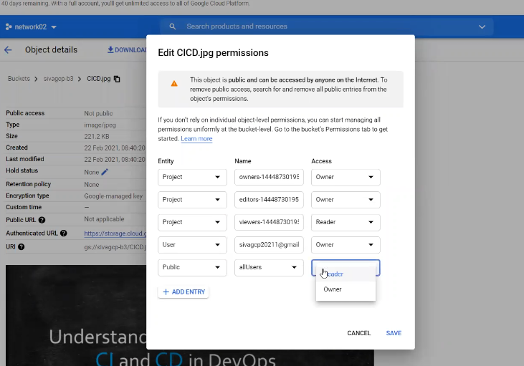

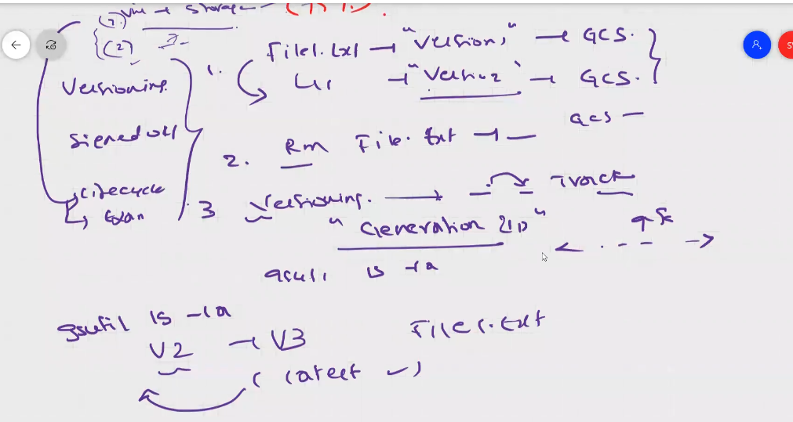

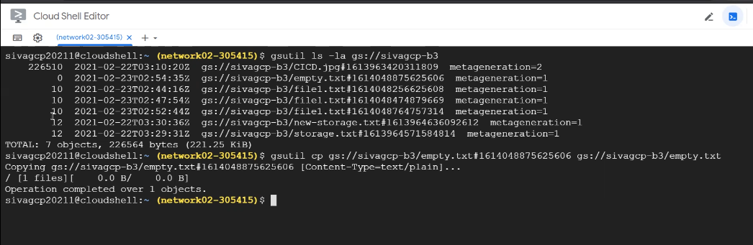

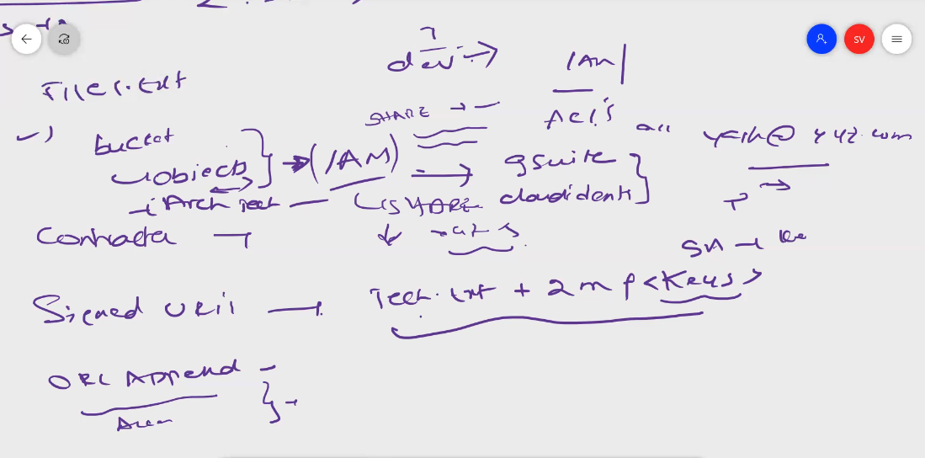

Signed url – to provide shared folder or files access to outside the domain users

Can share using command line only

User should have email id or through IAM, if no email id we can give access for a particular time using keys, and can access for a particular time, only for a limited time access we can use signed URLs